Determinants of Exclusive Breastfeeding Practices Among First-Time Mothers Attending Maternal and Child Health Clinics at Nyeri County Referral Hospital, Nyeri County, Kenya
AUGUST, 2026
BY
- ROP ROY BSN-1-5522-3/2021
- GIDEON EINSTEIN BSN-1-0411-3/2022
- SHEM KEMBOI BSN-1-4574-3/2022
- KIPTOO OLIVER BSN-1-4572-3/2022
- KIMENCHU JEFF MAYAKA BSN-1-8154-3/2019
RESEARCH PROJECT SUBMITTED TO THE DEPARTMENT OF NURSING IN PARTIAL FULFILMENT FOR THE AWARD OF BACHELOR OF SCIENCE IN NURSING AT KENYA METHODIST UNIVERSITY

DECLARATION
We hereby declare that this research project is our original work and has not been submitted for any degree or diploma in any other university.
Name | Registration Number | Signature | Date
ROP ROY | BSN-1-5522-3/2021
GIDEON EINSTEIN | BSN-1-0411-3/2022
SHEM KEMBOI | BSN-1-4574-3/2022
KIPTOO OLIVER | BSN-1-4572-3/2022
KIMENCHU JEFF MAYAKA | BSN-1-8154-3/2019

SUPERVISOR
This research project has been submitted for review with my approval as the University Supervisor.

Signature ……………………… Date ……………………………….

LAURENZIA NJERU
LECTURER, DEPARTMENT OF NURSING
SCHOOL OF HEALTH SCIENCES
KENYA METHODIST UNIVERSITY

DEDICATION
We dedicate this research project to Almighty God for His grace, guidance, and unwavering presence throughout our academic journey.
To our beloved parents and families, whose endless sacrifices, financial support, prayers, and encouragement have been the foundation upon which we have built our dreams. Your belief in us has been our greatest motivation.
To our dear supervisor, Madam Laurenzia Njeru, whose dedication, patience, and tireless efforts have shaped this work into what it is today. Your mentorship has been invaluable.

ACKNOWLEDGEMENT
We wish to express our sincere gratitude to Almighty God for His love, grace, and guidance throughout the development of this research project. He has been our source of strength and inspiration throughout this journey.
We extend our heartfelt appreciation to our supervisor, Madam Laurenzia Njeru, for her invaluable guidance, constructive feedback, patience, and unwavering support. Her expertise, dedication, and mentorship have been instrumental in shaping this work from conception to completion.
We are grateful to the Department of Nursing at Kenya Methodist University for providing us with the necessary resources and academic environment to conduct this research. Special thanks to the faculty members and lecturers who have imparted knowledge and skills that have prepared us for this undertaking.
We acknowledge the administration of Nyeri County Referral Hospital for granting us permission to conduct this study at their facility, and the MCH clinic staff for their cooperation and support during data collection.
We thank our families and friends for their continuous financial, spiritual, and moral support throughout this journey. Your belief in us and this work has been a constant source of motivation. To our friends and classmates, thank you for your support and encouragement during the demanding phases of this research project.
Lastly, we thank all the first-time mothers who participated in this study. Your willingness to share your experiences and insights will contribute to improving breastfeeding support for future mothers in Nyeri County and beyond.

ABSTRACT
Exclusive breastfeeding (EBF) is recognized globally as one of the most effective interventions for reducing child mortality and morbidity. Despite its well-documented benefits, EBF rates remain suboptimal, particularly among first-time mothers who face unique challenges in establishing and maintaining breastfeeding. In Kenya, EBF rates have stagnated at 60% for a decade, below the national target of 80%. At Nyeri County Referral Hospital (NCRH), the MCH clinic serves a significant number of first-time mothers, yet facility-specific data on EBF determinants has been limited, hindering the development of targeted interventions. To determine the determinants of exclusive breastfeeding practices among first-time mothers attending Maternal and Child Health clinics at Nyeri County Referral Hospital, Nyeri County, Kenya. A descriptive cross-sectional study design was employed using quantitative methods. A sample of 60 first-time mothers with infants aged above 6 months attending the MCH clinic at NCRH was recruited using systematic random sampling. Data were collected using a structured researcher-administered questionnaire covering socio-demographic characteristics, client-related factors, and health facility-related factors. Data were analysed descriptively using Microsoft Excel and presented using frequency tables, percentages, and figures. The study achieved a response rate of 96.7% (58 respondents). The majority of respondents were aged 20-24 years (44.8%), married (55.2%), had secondary education (37.9%), and earned below KES 25,000 monthly (58.6%). Overall, 37.9% of respondents exclusively breastfed for six months. Partner support was reported by 79.2% of respondents, while 48.3% faced family pressure to give other foods or liquids. Pre-lacteal feeding was reported by 34.5%, with family members being the primary advisors (60.0%). Over half (51.7%) demonstrated good knowledge of EBF, while only 43.1% received help with positioning and attachment from healthcare workers. Distance (34.5%) and cost (24.1%) were identified as barriers. The main reasons for early cessation were baby crying (33.3%), family advice (27.8%), and perceived insufficient milk (22.2%). The study found an EBF rate of 37.9% among first-time mothers at NCRH, significantly below the national target of 80%. Client-related factors (family pressure, pre-lacteal feeding, knowledge-practice gap) and health facility-related factors (inadequate breastfeeding counselling and positioning/attachment support) were identified as major determinants. Socio-demographic factors, particularly income and early return to work, also contributed to low EBF rates. The Ministry of Health should strengthen policies on workplace lactation support and maternity leave. Nyeri County Referral Hospital should enhance breastfeeding counselling during ANC and PNC, improve positioning and attachment support, and engage family members in breastfeeding education. Community health volunteers should conduct household-level outreach to address cultural beliefs and engage partners and mothers-in-law in supporting EBF. Future research should explore the lived experiences of first-time mothers through qualitative studies and evaluate the effectiveness of community-based breastfeeding interventions.
Keywords: Exclusive breastfeeding, first-time mothers, determinants, Nyeri County Referral Hospital, Kenya.

TABLE OF CONTENTS
DECLARATION I
SUPERVISOR I
DEDICATION II
ACKNOWLEDGEMENT III
ABSTRACT IV
TABLE OF CONTENTS V
LIST OF FIGURES IX
LIST OF TABLES X
ACRONYMS AND ABBREVIATIONS XI
OPERATIONAL DEFINITION OF TERMS XII
CHAPTER ONE 1
INTRODUCTION 1
1.1 Background of the Study 1
1.2 Problem Statement 2
1.3 Objectives of the Study 3
1.3.1 Broad Objective 3
1.3.2 Specific Objectives 3
1.4 Research Questions 3
1.5 Significance of the Study 3
1.6 Scope and Limitations 4
1.6.2 Limitations of the Study 4
1.6.3 Delimitations of the Study 5
CHAPTER TWO 6
LITERATURE REVIEW 6
2.1 Introduction 6
2.2 Socio-Demographic Characteristics and Exclusive Breastfeeding 6
2.3 Client Related Factors Influencing Exclusive Breastfeeding Among First-Time Mothers 8
Partner and Family Support 8
Cultural Beliefs and Pre-lacteal Feeding 9
2.4 Health Facility Related Factors Affecting Exclusive Breastfeeding Among First-Time Mothers 11
2.5 Theoretical Framework 14
2.6 Conceptual Framework 15
2.6.1 Independent Variables 15
2.6.2 Intervening Variables 16
2.6.3 Dependent Variable 16
CHAPTER THREE 17
RESEARCH METHODOLOGY 17
3.0 Introduction 17
3.1 Study Area 17
3.2 Research Design 17
3.3 Target Population 18
3.4.1 Inclusion Criteria 18
3.4.2 Exclusion Criteria 18
3.4 Sample Size Determination 18
3.5 Sampling Technique 19
3.6 Data Collection Instrument 20
3.7 Data Collection Timing 20
3.8 Pre-Test 20
3.9 Reliability and Validity of Research Instruments 21
3.9.1 Reliability 21
3.9.2 Validity 21
3.10 Data Collection Process 21
3.11 Ethical Considerations 23
3.12 Data Analysis and Presentation 23
CHAPTER FOUR 24
RESEARCH FINDINGS AND ANALYSIS 24
4.1 Introduction 24
4.2 Response Rate 24
4.3 Socio-Demographic Characteristics of Respondents 24
4.3.1 Age of Respondents 24
4.3.2 Highest Level of Education 26
4.3.3 Marital Status 26
4.3.4 Current Occupation 27
4.3.5 Average Monthly Household Income 28
4.3.6 Place of Residence 28
4.3.7 Religion 29
4.3.8 Employment and Return to Work 29
4.4 Client-Related Factors Influencing Exclusive Breastfeeding 30
4.4.1 Partner Support 30
4.4.2 Family Pressure 31
4.4.3 Cultural Beliefs 33
4.4.4 Pre-lacteal Feeding 34
4.4.5 Maternal Knowledge of Exclusive Breastfeeding 36
4.5 Health Facility-Related Factors Affecting Exclusive Breastfeeding 37
4.5.1 Antenatal Care (ANC) Attendance 37
4.5.2 Place of Delivery and Postnatal Care 38
4.5.3 Perceived Healthcare Worker Support and Facility Accessibility 41
4.6 Exclusive Breastfeeding Practices Among First-Time Mothers 42
4.6.1 Breastfeeding Initiation 42
4.6.3 Complementary Feeding and Breastfeeding on Demand 45
CHAPTER FIVE 46
DISCUSSION, CONCLUSION AND RECOMMENDATIONS 46
5.1 Discussion 46
5.1.1 Response Rate 46
5.1.2 Socio-Demographic Characteristics 46
5.1.3 Client-Related Factors 46
5.1.4 Health Facility-Related Factors 47
5.1.5 Exclusive Breastfeeding Practices 47
5.2 Conclusion 47
5.3 Recommendations 48
5.3.1 Recommendations to the Ministry of Health and Policy Makers 48
5.3.2 Recommendations to Nyeri County Referral Hospital and Healthcare Workers 49
5.3.3 Recommendations to First-Time Mothers, Families and the Community 49
5.3.4 Recommendations for Future Research 49
REFERENCES 51
APPENDICES 55
APPENDIX I: WORK PLAN 55
APPENDIX II: BUDGET 56
APPENDIX III: INFORMED CONSENT FORM 58
APPENDIX IV: QUESTIONNAIRES. 59
APPENDIX V: INTRODUCTION LETTER. 73

LIST OF FIGURES
Figure 1. Conceptual Framework 15
Figure 2: Age Distribution of Respondents 25
Figure 3:Marital Status Distribution 27
Figure 4:Age of Baby at Mother's Return to Work 30
Figure 5:Partner Support Categories 31
Figure 6:Sources of Family Advice on Feeding 32
Figure 7:Types of Foods/Liquids Family Members Pressure Mothers to Give 33
Figure 8:Beliefs About Colostrum 34
Figure 9:Pre-lacteal Feeding Practice 36
Figure 10:Knowledge Levels of Exclusive Breastfeeding 37
Figure 11:Number of ANC Visits Attended 38
Figure 12:Place of Delivery 40
Figure 13:Facility-Based Breastfeeding Support Received 40
Figure 14:Perceived Barriers to Accessing Breastfeeding Support 41
Figure 15:Time of Breastfeeding Initiation 42
Figure 16:Exclusive Breastfeeding Status at Six Months 44
Figure 17:Reasons for Early Introduction of Liquids/Solids 44

LIST OF TABLES
Table 2: Age of Respondents 29
Table 3: Highest Level of Education 31
Table 4:Marital Status 31
Table 5:Current Occupation 32
Table 6:Average Monthly Household Income 33
Table 7:Place of Residence 33
Table 8:Religious Affiliation 34
Table 9:Age of Baby When Mother Returned to Work 34
Table 10:Partner Support for Breastfeeding 36
Table 11:Family Involvement and Pressure on Infant Feeding 37
Table 12:Cultural Beliefs Around Breastfeeding 39
Table 13:Do Cultural Beliefs Discourage Early ANC Attendance? 39
Table 14:Pre-lacteal Feeding Practice 40
Table 15:Overall Maternal Knowledge of Exclusive Breastfeeding 42
Table 16:Number of ANC Visits Attended 43
Table 17:Place of Delivery 44
Table 18:Postnatal Care and Breastfeeding Support at the Facility 45
Table 19:Perceived Facility Support and Accessibility 47
Table 20:Time of Breastfeeding Initiation 48
Table 21:Exclusive Breastfeeding Status at Six Months 49
Table 22:Reasons for Introducing Liquids/Solids Before Six Months 49
Table 23:Age at Introduction of Complementary Foods 51

ACRONYMS AND ABBREVIATIONS
ANC - Antenatal Care
BSN - Bachelor of Science in Nursing
CHV - Community Health Volunteer
EBF - Exclusive Breastfeeding
KeMU- Kenya Methodist University
KNBS - Kenya National Bureau of Statistics
MCH - Maternal and Child Health
MOH - Ministry of Health
NCRH - Nyeri County Referral Hospital
PNC - Postnatal Care
SDG - Sustainable Development Goal
TPB - Theory of Planned Behavior
UNICEF - United Nations Children's Fund
WHO - World Health Organization

OPERATIONAL DEFINITION OF TERMS
Client-Related Factors – Factors related to the mother and her environment that influence exclusive breastfeeding, including socio-cultural influences, maternal factors, and infant factors.
Determinants – Factors that influence exclusive breastfeeding practices among first-time mothers, categorized into client-related factors, knowledge factors, and health facility-related factors.
Exclusive Breastfeeding (EBF) – An infant receiving only breast milk and no other liquids or solids for the first six months of life, except prescribed medicines. Assessed using the 24-hour recall method.
First-Time Mother (Primiparous Woman) – A woman who has given birth to only one child and has no other living children. This study includes those with infants aged 0-6 months attending MCH clinic at NCRH.
Health Facility-Related Factors – Healthcare-related factors affecting exclusive breastfeeding, including ANC attendance, place of delivery, PNC follow-up, breastfeeding counseling, and healthcare worker support.
Knowledge – A mother's level of awareness and understanding of exclusive breastfeeding, including its definition, benefits, duration, techniques, and risks of mixed feeding.
Maternal and Child Health (MCH) Clinic – The outpatient department at NCRH providing immunization, growth monitoring, nutrition counseling, and health education to mothers and children under five years.
Pre-lacteal Feeding – Any food or liquid given to a newborn before breastfeeding has been initiated, including water, glucose, herbal mixtures, or formula.
Postnatal Care (PNC) – Healthcare services provided to the mother and newborn within the first six weeks after delivery.
Socio-Demographic Characteristics – Background characteristics of first-time mothers including age, education level, marital status, occupation, monthly income, and place of residence.
24-Hour Recall Method – A WHO-recommended method where mothers report all foods and liquids given to their infant in the previous 24 hours to assess breastfeeding practices.

CHAPTER ONE

INTRODUCTION

1.1 Background of the Study
Breastfeeding is recognized globally as the cornerstone of child survival, growth, and development. The World Health Organization (WHO) and the United Nations Children's Fund (UNICEF) recommend initiation of breastfeeding within the first hour of birth and exclusive breastfeeding for the first six months of life, with continued breastfeeding for up to two years or beyond. Exclusive breastfeeding (EBF) is defined as an infant receiving only breast milk and no other liquids or solids, with the exception of oral rehydration solutions, vitamins, minerals, or medicines. This practice provides essential, irreplaceable nutrition for a child's growth and development, serves as a child's first immunization, and has a protective effect against obesity and certain non-communicable diseases later in life. (Victora et al., 2016). Globally, universal breastfeeding could prevent an additional 520,000 deaths annually and save the global economy $300 billion USD (Walters et al., 2019).
Breastfeeding prevents about 823,000 deaths of children under five years of age annually around the world (Victora et al., 2016), decreases mortality due to infections by 88 percent in infants younger than three months, and admissions to hospitals due to diarrhea by 72 percent and respiratory infections by 57 percent (Rollins et al., 2016). Nevertheless, global EBF rates are still not optimal at 48% (UNICEF & WHO, 2023), falling short of the 60-80% target expected by 2030 as set by the World Health Assembly (WHO, 2024). Sub-Saharan Africa is a worrying scenario since the region is the source of more than 90 percent of under-five deaths in the world (UNICEF, 2023). Research demonstrates that the knowledge-practice gap has persisted, as awareness alone is not enough to ensure optimal breastfeeding practices (Kimani-Murage et al., 2015). In sub-Saharan Africa, EBF rates range from 18% in Chad to 70% in Rwanda (Biks et al., 2021). East Africa rates are: Rwanda 70%, Uganda 66%, Tanzania 59%, and Kenya 60% (UNICEF, 2023).
In Kenya, EBF rates have remained at 60% for a decade, which is lower than the national target of 80% (Ministry of Health, 2020). First-time mothers face unique difficulties, with EBF rates of 39% in northern Kenya (Mohamed et al., 2018) and 45% in western Kenya (Talbert et al., 2020), compared to multiparous women. Studies have shown that first-time mothers experience problems such as breast pain, lack of breastfeeding skills, and perceived insufficient milk, and are frequently advised by family members to supplement breastfeeding, which poses barriers to EBF (Muthoni & Mwangi, 2021).
There are various factors affecting breastfeeding at individual, social, and health systems levels (Kimani-Murage et al., 2015; Wanjohi et al., 2017). A survey in Igembe Sub-county in Meru County found unacceptably low EBF prevalence of just 18.6%, with obstacles such as family pressure, the practice of pre-lacteal feeds, maternal workload, and prolonged separation of mother and infant (Macharia, Ochola, & Mutua, 2020).
Nyeri County Referral Hospital (NCRH) serves as a key health facility in the Central region of Kenya, providing comprehensive maternal and child health services to a diverse population from Nyeri County and surrounding areas. The hospital's MCH clinic attends to a significant number of first-time mothers, making it an ideal setting to investigate breastfeeding practices. Considering the persistently low rates of EBF in parts of Kenya and the specific challenges faced by first-time mothers, this study aims to establish the determinants affecting exclusive breastfeeding among this population at NCRH. The findings will contribute to the evidence base needed to implement interventions that result in better breastfeeding outcomes (Ministry of Health, 2024).

1.2 Problem Statement
Exclusive breastfeeding in the first six months of life is one of the most effective measures for reducing child mortality and morbidity globally. The World Health Organization estimates that compliance with best breastfeeding practices could prevent approximately 823,000 deaths annually in children under five, with the highest proportion of these deaths occurring in low- and middle-income countries. Despite this strong evidence, global rates of exclusive breastfeeding are not optimal at 48%, with sub-Saharan Africa having extremely low rates.
In Kenya, EBF rates have stagnated at 60% for a decade, below the national target of 80% (KNBS, 2023; Ministry of Health, 2020). In Meru County, a study in Igembe Sub-county found EBF prevalence of only 18.6%, with barriers including family pressure, pre-lacteal feeding, maternal workload, and mother-infant separation (Macharia et al., 2020). First-time mothers face additional challenges such as breastfeeding difficulties, perceived milk insufficiency, and conflicting family advice (Muthoni & Mwangi, 2021).
At Nyeri County Referral Hospital (NCRH), the MCH clinic serves a significant number of first-time mothers. According to hospital records for the year 2025, a total of 1,850 first-time mothers attended the MCH clinic for immunization and child welfare services. This represents approximately 42% of the total 4,400 mothers who attended the clinic during the same period. While a few studies have been conducted on maternal and child health in Nyeri County and the broader Central region, limited research has specifically focused on the determinants of exclusive breastfeeding practices among first-time mothers attending the MCH clinic at NCRH. Studies from other parts of Kenya have documented EBF rates as low as 39% among first-time mothers in northern Kenya and 45% in western Kenya (Mohamed et al., 2018; Talbert et al., 2020), yet facility-specific data for NCRH remains scarce. This gap hinders the development of targeted, evidence-based interventions. Therefore, this study seeks to answer: What are the determinants of exclusive breastfeeding practices among first-time mothers attending MCH clinics at Nyeri County Referral Hospital?

1.3 Objectives of the Study

1.3.1 Broad Objective
To assess the determinants of exclusive breastfeeding practices among first-time mothers attending Maternal and Child Health clinics at Nyeri County Referral Hospital.

1.3.2 Specific Objectives
- To assess the maternal socio-demographic characteristics as factors affecting exclusive breastfeeding practices among first-time mothers attending Maternal and Child Health clinics at Nyeri County Referral Hospital.
- To assess the client-related factors influencing exclusive breastfeeding practices among first-time mothers attending Maternal and Child Health clinics at Nyeri County Referral Hospital.
- To assess the health facility-related factors affecting exclusive breastfeeding practices among first-time mothers attending Maternal and Child Health clinics at Nyeri County Referral Hospital.

1.4 Research Questions
The study was guided by the following research questions:
- What are the maternal socio-demographic characteristics affecting exclusive breastfeeding practices among first-time mothers attending MCH clinics at Nyeri County Referral Hospital?
- What are the client-related factors influencing exclusive breastfeeding practices among first-time mothers attending MCH clinics at Nyeri County Referral Hospital?
- What are the health facility-related factors affecting exclusive breastfeeding practices among first-time mothers attending MCH clinics at Nyeri County Referral Hospital?

1.5 Significance of the Study
The results of the proposed research will be of importance to different stakeholders:
Ministry of Health: The research will furnish evidence-based data to shape policies and guidelines addressing breastfeeding among first-time mothers in Nyeri County and beyond, supporting Kenya's national target of increasing exclusive breastfeeding rates to at least 60% by 2030.
Nyeri County Referral Hospital: The hospital will gain knowledge on the particular determinants that affect exclusive breastfeeding among first-time mothers, which will lead to the formulation of suitable interventions and enhancement of breastfeeding support services in the MCH clinic.
Healthcare Workers: Nurses, midwives, and other health practitioners will learn more about the special needs of primiparous mothers and will be able to provide better counseling and assistance.
First-Time Mothers and Families: The main beneficiaries will be first-time mothers and their babies, as the results will inform interventions tailored to this population, thus improving breastfeeding outcomes.
Community of Nyeri County: The community will benefit from improved child health outcomes due to enhanced exclusive breastfeeding practices, with findings informing community-based interventions involving family members and community leaders.
Policy Makers: This study will provide policy makers with evidence-based data to inform maternal and child health policies addressing breastfeeding among first-time mothers.
Future Researchers: This study will provide baseline data for future research, including intervention studies and qualitative studies on first-time mothers' breastfeeding experiences.

1.6 Scope and Limitations
The current research study was conducted at Nyeri County Referral Hospital (NCRH), a Level 5 healthcare facility serving Nyeri County and the surrounding region. The target population included primiparous women whose infants are aged above 6 months and who visit the Maternal and Child Health (MCH) clinic. The study examined three categories of determinants: maternal socio-demographic characteristics, health facility-related factors, and client-related factors. A cross-sectional descriptive design using a quantitative research approach was followed, with data gathered through a structured researcher-administered questionnaire. Data collection took approximately two weeks.

1.6.2 Limitations of the Study
Cross-ross-sectional design: The researchers could only describe the determinants at a single point in time. Therefore, the results are described in descriptive terms, and suggestions regarding longitudinal research are provided.
Self-report bias: The mothers were likely to over-report exclusive breastfeeding due to social desirability. The research used the 24-hour recall as proposed by WHO and guaranteed the confidentiality of answers in order to promote truthful responses.
Single-site research: Results might not be generalizable to other organizations. However, the description of the site and the characteristics of the participants were detailed to allow assessment of external validity.
Language barrier: Some participants may have had limited proficiency in English. The questionnaire was translated to Kiswahili by research assistants fluent in the language.

1.6.3 Delimitations of the Study
Only first-time mothers whose babies were aged above 6 months and who attended Nyeri County Referral Hospital were included in the present study. Mothers with multiple pregnancies were excluded, as were mothers with infants aged 0-6 months. The study was confined to the scope of exclusive breastfeeding and a purely quantitative methodology approach was used.

CHAPTER TWO

LITERATURE REVIEW

2.1 Introduction
This chapter presents a review of literature relevant to the determinants of exclusive breastfeeding practices among first-time mothers. The literature is organized thematically according to the study objectives: maternal socio-demographic characteristics, client-related factors and health facility-related factors. Each section presents global, African, and Kenyan findings. The chapter also presents the theoretical framework (Theory of Planned Behavior) and conceptual framework guiding the study.
Exclusive breastfeeding practices vary significantly across the globe. Globally, the World Health Organization and UNICEF report that only 48% of infants under six months are exclusively breastfed, despite strong evidence of its benefits (UNICEF & WHO, 2023). In Africa, the prevalence of exclusive breastfeeding varies widely, with countries such as Rwanda achieving rates as high as 70%, while others like Chad report rates as low as 18% (Biks et al., 2021). In Kenya, national EBF rates have stagnated at 60% for a decade, with significant regional disparities; for instance, Central region reports rates as high as 75%, while Nairobi reports only 45% (KNBS, 2023). In Nyeri County, the Ministry of Health has implemented various maternal and child health programs to improve breastfeeding practices. According to the Kenya Demographic and Health Survey (KDHS) 2022, the Central region, where Nyeri County is located, reports EBF rates as high as 75%, which is above the national average of 60% (KNBS, 2023). This suggests that while the region performs relatively well compared to other parts of Kenya, there may still be gaps at the facility level, particularly among first-time mothers. Studies conducted in the broader Central region have identified cultural beliefs, family support, and health facility factors as significant determinants of EBF practices (Njoroge & Kimani, 2022). However, specific data on EBF among first-time mothers attending Nyeri County Referral Hospital remains limited, highlighting the need for this study.

2.2 Socio-Demographic Characteristics and Exclusive Breastfeeding
Socio-demographic characteristics, including maternal age, education level, marital status, occupation, income, and place of residence, have been consistently associated with exclusive breastfeeding practices (Omondi & Otieno, 2023; Victora et al., 2016).
Globally, socio-demographic factors are among the strongest predictors of EBF. Maternal age shows a complex relationship with EBF. Adolescent mothers (15-19 years) have significantly lower EBF rates compared to mothers aged 20-29 years (Victora et al., 2016). A 2024 systematic review found that adolescent mothers face unique challenges including lack of breastfeeding experience, lower confidence, and less support from partners and family (Mboya et al., 2024).
Education level is consistently associated with EBF. A 2023 systematic review found that mothers with secondary or higher education were more likely to practice EBF compared to those with no formal education (Agho et al., 2023). However, education alone does not guarantee practice; in urban settings, educated mothers who returned to work had lower EBF rates, suggesting that education must be combined with workplace support (Kimani-Murage et al., 2015).
Marital status influences breastfeeding through partner support. A meta-analysis of 28 studies found that married mothers or those with supportive partners were 1.8 times more likely to practice EBF compared to single mothers (Pérez-Escamilla et al., 2018). Partner support includes encouragement, assistance with household chores, and participation in breastfeeding education.
Income and employment status significantly affect EBF. A 2025 analysis of 25 Sub-Saharan African countries found that wealthier households had significantly higher odds of EBF (Biks et al., 2025). Employed mothers often face challenges maintaining EBF due to early return to work and lack of workplace lactation facilities (Gichuhi et al., 2021).
In sub-Saharan Africa, socio-demographic factors are significant determinants of EBF. A multi-country analysis of 25 countries found a pooled EBF prevalence of 49%, with wealthier households having higher odds of EBF (middle: AOR = 1.41; richer: AOR = 1.54; richest: AOR = 1.46) (Biks et al., 2025). Rural residence was associated with higher EBF odds compared to urban areas, possibly due to stronger traditional support systems and lower rates of early return to work.
In Ethiopia, a study found that mothers with secondary or higher education were more likely to practice EBF compared to those with no formal education (Tewabe, 2016). In Nigeria, adolescent mothers had EBF rates of only 28% compared to 52% among older mothers (Agho et al., 2023).
In Kenya, socio-demographic factors have been identified as significant determinants of EBF. A 2024 population-based survey of 2,842 mother-infant pairs found that younger age (<25 years) and lower education were associated with lower EBF prevalence at 6-weeks (Diakhate et al., 2024). The study also found that 6-month EBF prevalence was 14% lower in women reporting mild or above depressive symptoms and 15% lower in women with a history of intimate partner violence (Diakhate et al., 2024).
In Meru County, a study found that maternal education and income were significantly associated with EBF practices (Macharia et al., 2020). In Kisumu, first-time mothers lack breastfeeding experience and confidence compared to multiparous mothers (Omondi & Otieno, 2023). A 2022 study at Pumwani Hospital found that demographic factors influencing EBF included age of both mother and father, levels of education, religion, and marital status (Cherop & Kipruto, 2022).
In Nyeri County, a study conducted by Njoroge and Kimani (2022) in the Central region found that maternal age, education level, and attendance at postnatal care were significant predictors of exclusive breastfeeding. The study reported that mothers who attended postnatal care within the first week after delivery were three times more likely to practice exclusive breastfeeding compared to those who did not. Additionally, socio-cultural factors such as family support and cultural beliefs about colostrum were found to influence breastfeeding decisions among mothers in the region.

2.3 Client Related Factors Influencing Exclusive Breastfeeding Among First-Time Mothers
Client-related factors are among the strongest and most consistently reported determinants of exclusive breastfeeding (EBF) globally. These include socio-cultural influences, knowledge, partner support, family pressure, cultural beliefs, and pre-lacteal feeding practices.
A 2025 systematic review and meta-analysis of 38 articles, encompassing 70,183 participants, identified seven key predictive factors for EBF: mother's awareness of breastfeeding benefits, support received in breastfeeding and child-rearing, early breastfeeding after birth, mother's education level, annual income, mother's age, and prenatal care (Kalhor et al., 2025). The meta-analysis showed that maternal awareness of breastfeeding benefits increased the odds of EBF by 2.70 times (95% CI 1.68, 1.54), support in child-rearing by 2.57 times, early breastfeeding (<24 hours) by 1.85 times, and higher education level by 1.44 times (Kalhor et al., 2025).

Partner and Family Support
Maternal support from partners, family, and the community is consistently identified as a critical determinant. A 2025 systematic review found that mothers who received strong support were 2.57 times more likely to practice EBF (Kalhor et al., 2025). A 2024 qualitative study in South Africa among primigravida mothers identified personal, social, and environmental factors as strongly influencing maternal attitudes toward breastfeeding efficacy (Naicker et al., 2024).
A 2021 study in South Africa exploring the support available to first-time mothers found that first-time mothers received practical support mainly from nurses and other mothers during breastfeeding initiation, while social support came from family members, friends, and community members for maintenance (Naicker et al., 2021). However, there was sometimes a disjuncture between practical support from nurses and that from family members and the community, with instances where support was needed but not given or not supportive of EBF (Naicker et al., 2021).
A 2025 study from Ghana exploring psychosocial factors among first-time mothers found that lactation problems, pain in the nipple and back, and difficulty positioning the baby were major stressors (Amekpor et al., 2025). While most first-time mothers were aware of EBF recommendations, they struggled with practical implementation at home. The study revealed that family support was crucial, with mothers who received maximum physical and emotional support from immediate family members more likely to continue EBF. However, some participants reported that family members, particularly mothers-in-law, discouraged EBF by insisting on giving water or traditional remedies (Amekpor et al., 2025).

Cultural Beliefs and Pre-lacteal Feeding
Pre-lacteal feeding (giving water, herbs, or honey before breastmilk) is reported by 32% of mothers globally, with rates as high as 60% in some regions (Lamberti et al., 2013). A 2025 analysis of 25 Sub-Saharan African countries found that cultural beliefs and practices significantly influence EBF outcomes (Biks et al., 2025). In sub-Saharan Africa, an analysis of 25 countries using Demographic and Health Survey data (2010-2023), involving 17,431 women aged 15-49 years, found a pooled EBF prevalence of 49%, ranging from 83% in Burundi to 19% in Gabon (Biks et al., 2025).
Cultural beliefs about colostrum remain prevalent across Africa. A study across five African countries found that 45% of mothers discard colostrum, believing it is "dirty" (Mogre et al., 2021). A 2026 integrative review of 19 studies from Nigeria found that primary barriers included cultural myths—viewing colostrum as "dirty" or breastmilk as "insufficient" without water—and lack of spousal/family support (Abiodun et al., 2026).
In sub-Saharan Africa, cultural beliefs strongly influence EBF. A study across five African countries found that 45% of mothers discard colostrum, believing it is "dirty" (Mogre et al., 2021). In Ethiopia, mothers with partner and mother-in-law support were 2.5 times more likely to practice EBF (Tewabe, 2016). In Nigeria, adolescent mothers had EBF rates of only 28% compared to 52% among older mothers (Agho et al., 2023).
A 2020 systematic review of East Africa found that while knowledge levels were generally high (82%), practice remained low at 45% (Mgongo et al., 2020). Key barriers included perceived insufficient milk supply, infant weight gain concerns, cultural beliefs about colostrum, family pressure to introduce other foods, and difficulties returning to work or school (Mgongo et al., 2020).
Cultural beliefs and socio-cultural factors remain powerful determinants. A 2020 qualitative study in Wajir County, Kenya, found that despite high knowledge and positive attitudes towards EBF, the practice was unsatisfactory (Mohamed et al., 2020). The major hindrances identified were cultural barriers propagated by mothers-in-law and traditional birth attendants; the belief that babies cannot live without water; and a few unsupportive health workers (Mohamed et al., 2020). The uptake of EBF was enhanced by Islamic teaching on breastfeeding, education from a few supportive healthcare providers, support from husbands, and positive deviance among some lactating mothers who practiced EBF (Mohamed et al., 2020).
In Kenya, family pressure is a major barrier. A study in Wajir County (2020) found that despite high knowledge and positive attitudes toward EBF, practice was unsatisfactory (Mohamed et al., 2020). The major hindrances identified were cultural barriers propagated by mothers-in-law and traditional birth attendants, and the belief that babies cannot live without water. The study recommended strengthening community health strategies through training traditional birth attendants on infant and young child nutrition practices.
In Meru County, 40% of mothers discard colostrum and 35% practice pre-lacteal feeding (Macharia et al., 2020). Partner support is critical; first-time mothers with supportive partners are more likely to continue EBF (Talbert et al., 2020). A longitudinal study in rural Kenya (2020) found that among 20 first-time mothers followed for six months, only two exclusively breastfed from birth to six months. Prelacteal feeds, home remedies, and traditional medicines were given by over a third of mothers in the first week of life. The study also found persistent problems with positioning and attachment of infants during breastfeeding observation.
A 2021 qualitative study in Naivasha, Kenya, found that despite recognizing the recommended duration for EBF, employed mothers described early cessation of EBF in preparation for their return to work (Muthoni & Mwangi, 2021). Few workplaces had lactation spaces, and most managers considered adjusting schedules more feasible than providing breastfeeding breaks. The most frequently suggested interventions for improving EBF duration were expanding schedule flexibility, providing on-site daycare, workplace lactation rooms, improving milk expression education, and increasing maternity leave length (Muthoni & Mwangi, 2021).
A 2026 study in Nairobi's informal settlements found that mothers in more formalized marital unions during pregnancy had higher odds of EBF for six months (AOR 1.43, 95% CI 1.03-1.99) (Oketch et al., 2026). The study also found that union formalization was associated with higher odds of receiving partner support during pregnancy, particularly help with household chores, which mediated part of the association (Oketch et al., 2026).
A 2022 study in Nairobi found that while 83% of mothers had high levels of knowledge on EBF, only 37% practiced exclusive breastfeeding (Cherop & Kipruto, 2022). The study established that demographic factors influencing EBF included age of both mother and father, levels of education, religion, and marital status. Notably, 69.2% of mothers had a negative attitude towards exclusive breastfeeding, which had a significant statistical association with EBF practices (Cherop & Kipruto, 2022).
In Kisumu, first-time mothers lack breastfeeding experience and confidence compared to multiparous mothers (Omondi & Otieno, 2023).

2.4 Health Facility Related Factors Affecting Exclusive Breastfeeding Among First-Time Mothers
Health facility factors including antenatal care (ANC) attendance, place of delivery, postnatal care (PNC), and breastfeeding counselling significantly influence exclusive breastfeeding practices.
Globally, the World Health Organization and UNICEF have emphasized the critical role of health systems in supporting breastfeeding. The Global Breastfeeding Scorecard (2023) reported that only 48% of infants are exclusively breastfed, and highlighted that health facility factors—including skilled breastfeeding support during ANC and PNC—are key determinants of EBF success (UNICEF & WHO, 2023). The WHO's Baby-Friendly Hospital Initiative (BFHI) has been implemented in over 150 countries, with hospitals that achieve BFHI status reporting exclusive breastfeeding rates up to 20% higher than non-accredited facilities (WHO, 2021). The WHO Global Nutrition Targets 2025 and 2030 both emphasize strengthening health systems to provide breastfeeding counseling and support as a key strategy for increasing EBF rates (WHO, 2014; WHO, 2024). Furthermore, WHO recommendations for at least eight ANC contacts and early PNC within the first week after delivery are designed to provide opportunities for healthcare workers to address breastfeeding concerns before they lead to cessation (WHO, 2021).
A 2022 systematic review and meta-analysis of 58 studies across low- and middle-income countries found that mothers who attended four or more ANC visits were 2.1 times more likely to practice EBF compared to those who attended fewer visits (Kebede & Alemu, 2022). The review also reported that facility delivery was associated with a 2.3-fold higher likelihood of EBF compared to home delivery, and receipt of breastfeeding counselling during ANC increased EBF likelihood by 2.8 times (Kebede & Alemu, 2022).
A 2023 systematic review of 45 studies from Sub-Saharan Africa confirmed that early PNC within the first week was associated with significantly higher EBF rates, with mothers who received early PNC being 2.5 times more likely to practice EBF than those who did not (Nyasulu & Mwangalaba, 2023). The review emphasized that PNC provides a critical opportunity for healthcare workers to address breastfeeding problems, reassure mothers, and reinforce EBF messages before cessation occurs.
A 2024 randomized controlled trial in Ethiopia evaluated the effect of structured breastfeeding counselling delivered by trained nurses during ANC and PNC. The intervention group had an EBF rate of 79% at six months, compared to 52% in the control group (Tewabe et al., 2024). The study concluded that structured, repeated counselling that includes hands-on demonstration and problem-solving is far more effective than routine advice.
A 2025 analysis of 21 Sub-Saharan African countries using Demographic and Health Survey data found that place of delivery (AOR = 0.82; 95% CI 0.78, 0.87), postnatal checkup (AOR = 1.43; 95% CI 1.36, 1.51), and antenatal care attendance (AOR = 1.27; 95% CI 1.16, 1.39) were significantly associated with EBF practices (Biks et al., 2025). Additionally, community-level factors such as community literacy (AOR = 1.08; 95% CI 1.02, 1.15) and community media exposure (AOR = 1.06; 95% CI 1.01, 1.13) were also significantly associated with EBF outcomes, highlighting the importance of both individual and community-level health system interventions.
A 2024 study from Finland examining mothers discharged from Baby-Friendly hospitals found that adequate in-hospital postnatal breastfeeding support, including avoidance of non-medical supplementation, contributed to successful breastfeeding after hospital discharge (Mäkelä et al., 2024). Primiparous mothers needed emphasized support to mitigate breastfeeding difficulties, and timelier access to breastfeeding support after discharge was essential.
A 2023 study from China examining in-hospital formula feeding found that it was negatively associated with EBF (TE odds ratio = 0.47), with 28% of this association mediated by breastfeeding self-efficacy (Li et al., 2023). This highlights the importance of avoiding unnecessary formula supplementation during the birth hospital stay.
In Ethiopia, facility delivery increased EBF likelihood by 2.3 times, and breastfeeding counselling increased it by 2.8 times (Tewabe, 2016). In Uganda, mothers with four or more ANC visits had EBF rates of 72% compared to 48% with fewer visits (Nabulsi et al., 2019). In Tanzania, breastfeeding support within the first hour after delivery increased EBF at three months by 3.5 times (Mgongo et al., 2017). In Rwanda, strong health system support (91% facility delivery, 85% PNC attendance) contributes to 70% EBF rates (Biks et al., 2021).
A 2024 study from Finland examining mothers discharged from Baby-Friendly hospitals found that adequate in-hospital postnatal breastfeeding support, including avoidance of non-medical supplementation, contributed to successful breastfeeding after hospital discharge (Mäkelä et al., 2024). Primiparous mothers needed emphasized support to mitigate breastfeeding difficulties, and timelier access to breastfeeding support after discharge was essential.
A 2023 study from China examining in-hospital formula feeding found that it was negatively associated with EBF (TE odds ratio = 0.47), with 28% of this association mediated by breastfeeding self-efficacy (Li et al., 2023). This highlights the importance of avoiding unnecessary formula supplementation during the birth hospital stay.
In Kenya, facility delivery increased EBF likelihood by 2.1 times (Kimani-Murage et al., 2015). Early PNC within one week increased EBF at six weeks by three times (Kemboi & Cherotich, 2022). Breastfeeding counseling during ANC increased EBF at six months by 2.5 times, but only 55% of mothers received any counseling (Njoroge & Kimani, 2022). A Kenyan intervention trial increased EBF rates from 48% to 72% at six months using structured counseling (Kimani-Murage et al., 2020). At Meru Teaching and Referral Hospital, only 45% of mothers received any breastfeeding counseling during their hospital stay (Githinji et al., 2020).
The Wajir County study (2020) identified unsupportive health workers as a hindrance to EBF practice, while uptake was enhanced by education from supportive healthcare providers and support from husbands (Mohamed et al., 2020). The study recommended designing mechanisms linking traditional birth attendants to existing health facilities for support, and capacity building and monitoring to promote EBF.
A 2022 study at Pumwani Hospital in Nairobi found that 67% of mothers initiated breastfeeding within the first hour of delivery, but only 37% practiced exclusive breastfeeding (Cherop & Kipruto, 2022). The study recommended developing county-specific policy amendments to ensure adequate facilitation in health facilities towards the realization of exclusive breastfeeding requirements. Awareness drives were also recommended to address negative attitudes and their causes in the study area.
The longitudinal study in rural Kenya (2020) emphasized that prioritization of capacity to detect mothers with breastfeeding problems and provide breastfeeding education and support is necessary, particularly during the antenatal and early postnatal period. It is also important to engage with other women resident in the household who may offer conflicting feeding advice.
At Nyeri County Referral Hospital, there is limited documented evidence regarding the quality and extent of breastfeeding counseling provided to first-time mothers during their hospital stay. Given that only 45-55% of mothers nationally receive adequate breastfeeding counseling during ANC or PNC, this represents a significant gap that warrants investigation. This study will therefore assess the health facility-related factors affecting EBF practices among first-time mothers at NCRH.

2.5 Theoretical Framework
This study is guided by the Theory of Planned Behavior (TPB), which was developed by Icek Ajzen in 1991. The TPB is one of the most widely used theories for understanding and predicting health-related behaviours, including breastfeeding (Ajzen, 1991). A recent scoping review identified the TPB as one of the two most frequently employed theories in exclusive breastfeeding promotion research across 16 countries (Amoo et al., 2022).
The TPB posits that behavioural intention is the immediate antecedent of behaviour. In other words, the stronger a mother's intention to practice exclusive breastfeeding, the more likely she is to actually do so. This intention is determined by three key constructs: attitude toward the behaviour, subjective norm, and perceived behavioural control.
Attitude refers to the mother's positive or negative evaluation of exclusive breastfeeding. A mother who believes that breastfeeding is beneficial for her infant and herself is more likely to have a favorable attitude and, consequently, a stronger intention to breastfeed exclusively. Subjective norm refers to the mother's perception of social pressure from important people in her life, such as her partner, mother-in-law, healthcare workers, and community members. If she believes these important individuals support exclusive breastfeeding, her subjective norm will be favorable, strengthening her intention. Perceived behavioural control refers to the mother's confidence in her ability to successfully breastfeed exclusively despite challenges. This includes confidence in producing enough milk, managing breastfeeding difficulties such as engorgement or cracked nipples, and overcoming social or practical barriers such as returning to work or school.
In the context of this study, the TPB provides a useful framework for understanding how the identified determinants influence exclusive breastfeeding. Socio-demographic characteristics such as income, education, and employment status influence EBF practices by shaping the mother's perceived behavioural control and attitude; for instance, higher education may enhance knowledge and positive attitudes, while early return to work undermines confidence to continue breastfeeding. Client-related factors, such as family support and cultural beliefs, directly influence the mother's subjective norm by shaping her perception of what others expect. Knowledge regarding exclusive breastfeeding influences the mother's attitude by shaping her beliefs about the benefits and risks of EBF. Health facility-related factors, such as antenatal care attendance and breastfeeding counseling, influence the mother's perceived behavioural control by building her confidence and providing practical skills.
These three constructs; attitude, subjective norm, and perceived behavioural control, together shape the mother's intention to practice exclusive breastfeeding. This intention, in turn, is the strongest predictor of her actual EBF behaviour. The TPB has been successfully applied in breastfeeding research across multiple settings. A study in Iran found that the TPB constructs explained 47% of the variance in exclusive breastfeeding intention and 38% of the variance in EBF behaviour (Sharifi et al., 2024). In South Africa, perceived behavioural control was identified as the strongest predictor of EBF among first-time mothers, highlighting the importance of building maternal confidence (Naicker et al., 2024). Therefore, the TPB is an appropriate and relevant theoretical framework for this study.

2.6 Conceptual Framework
Based on the Theory of Planned Behavior and the literature reviewed, the conceptual framework below illustrates the relationships between the study variables.
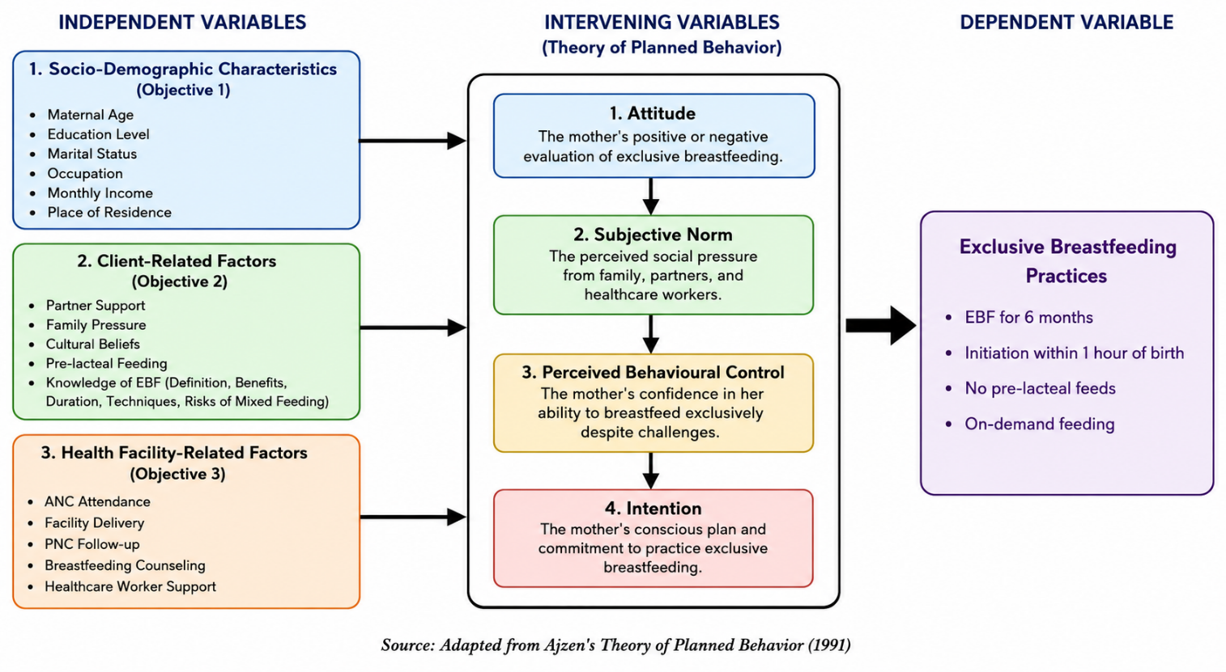
Figure 1. Conceptual Framework

2.6.1 Independent Variables
The independent variables in this study are categorized into three main groups, corresponding to the three specific objectives.
The first category is socio-demographic characteristics, which include maternal age, education level, marital status, occupation, monthly household income, and place of residence. These characteristics are hypothesized to be associated with EBF practices.
The second category is client-related factors, which include socio-cultural influences such as partner support, family pressure, cultural beliefs, and pre-lacteal feeding practices. Client-related factors also include maternal factors such as knowledge of EBF (definition, benefits, duration, techniques, and risks of mixed feeding), as well as maternal age and education (which are also captured in the socio-demographic category).
The third category is health facility-related factors, which include antenatal care attendance, the place of delivery (whether at a health facility or at home), postnatal care follow-up, whether the mother received breastfeeding counseling from healthcare workers, the perceived level of healthcare worker support, and access to maternal and child health services.

2.6.2 Intervening Variables
Based on the Theory of Planned Behavior, the relationship between the independent variables and exclusive breastfeeding practices is mediated by several intervening variables. These include the mother's attitude toward exclusive breastfeeding (her positive or negative evaluation of the practice), her perception of subjective norms (the social pressure she feels from family, partners, and healthcare workers regarding exclusive breastfeeding), her perceived behavioural control (her confidence in her ability to breastfeed exclusively despite challenges), and her intention to practice exclusive breastfeeding.

2.6.3 Dependent Variable
The dependent variable in this study is exclusive breastfeeding practices among first-time mothers. This is measured by several indicators: whether the mother practices exclusive breastfeeding for the first six months of the infant's life, whether she initiates breastfeeding within one hour of birth, whether she avoids giving pre-lacteal or post-lacteal feeds, and whether she practices on-demand feeding.
.

CHAPTER THREE

RESEARCH METHODOLOGY

3.0 Introduction
This chapter presents the research methodology used to investigate the determinants of exclusive breastfeeding practices among first-time mothers attending Maternal and Child Health clinics at Nyeri County Referral Hospital. It describes the research design, study area, target population, sampling techniques, data collection instruments, data analysis procedures, and ethical considerations. The methodology is structured to ensure the generation of reliable and valid data necessary to address the study objectives effectively.

3.1 Study Area
The study was carried out at Nyeri County Referral Hospital (NCRH), located in Nyeri County, Kenya. This government-run facility serves as the primary referral center for Nyeri County and the surrounding Central region. The hospital provides comprehensive maternal and child health services, including a well-established Maternal and Child Health (MCH) clinic that offers immunization, growth monitoring, nutrition counseling, and health education to mothers and children under five years.
NCRH was selected as the study site for several reasons. First, it provides comprehensive maternal and child health services, making it an ideal setting for studying breastfeeding practices. Second, the MCH clinic serves a significant number of first-time mothers daily, providing an adequate sampling frame for the study. Third, the hospital is accessible to the researchers from Kenya Methodist University, and the administration has expressed willingness to support research activities.
The MCH clinic at NCRH serves a diverse population of mothers from Nyeri County and surrounding areas, including both urban and rural communities, providing an excellent sampling frame for studying breastfeeding practices among first-time mothers.

3.2 Research Design
The study employed a descriptive cross-sectional research design using quantitative methods of data collection and analysis. This design was appropriate because it allowed for data collection at a single point in time, enabling the identification and analysis of various factors (Maternal socio-demographic characteristics, client-related factors, and health facility-related) that influence exclusive breastfeeding among first-time mothers. A cross-sectional design is cost-effective, time-efficient, and useful for informing policy and practice related to preventive health behaviors such as exclusive breastfeeding (Mugenda & Mugenda, 2012).
The study was quantitative in nature, using a structured researcher-administered questionnaire to collect data from first-time mothers who attended the MCH clinic at Nyeri County Referral Hospital.

3.3 Target Population
The target population for this study was 154 first-time mothers (primiparous women) with infants aged above 6 months attending the Maternal and Child Health (MCH) clinic at Nyeri County Referral Hospital.
According to Nyeri County Referral Hospital records for the year 2025, a total of 1,850 first-time mothers attended the MCH clinic for immunization and child welfare services. This represents approximately 42% of the total 4,400 mothers who attended the clinic during the same period. On average, the clinic receives approximately 154 first-time mothers per month (1,850 ÷ 12 months).

3.4 Inclusion and Exclusion Criteria

3.4.1 Inclusion Criteria
Participants were first-time mothers who had given birth to only one child and were over 18 years of age. Their infants must had been aged above 6 months at the time of data collection. This criterion was chosen to ensure that mothers had completed the recommended six-month exclusive breastfeeding period, allowing for accurate recall and assessment of their EBF practices. Mothers with infants aged 0-6 months were excluded because they were still within the EBF period and their final EBF status could not yet be determined. They must have attended the Maternal and Child Health (MCH) clinic at Nyeri County Referral Hospital during the data collection period. Additionally, they must have been willing to provide informed consent to participate in the study and must have been residents of Nyeri County for at least six months prior to the study.

3.4.2 Exclusion Criteria
Mothers were excluded from the study if they had infants who were critically ill or required urgent medical attention, as this would have interfered with their ability to participate fully. Additionally, mothers who declined to participate in the study and those who had not been residents of Nyeri County for at least six months were excluded from the study.

3.5 Sample Size Determination
The sample size was determined using Fisher's formula for cross-sectional studies:
n = Z² × p × (1-p) / e²
Where:
n = Initial sample size
Z = Z-score at 95% confidence level (1.96)
p = Estimated proportion of exclusive breastfeeding in Kenya (60% from KNBS, 2023)
e = Margin of error (5% = 0.05)
Calculation:
n = (1.96)² × (0.60) × (1-0.60) / (0.05)²
n = (3.8416) × (0.60) × (0.40) / (0.0025)
n = 0.9220 / 0.0025
n = 368.8 ≈ 369 participants
Since the target population was less than 10,000, the sample size was adjusted using the finite population correction formula:
Nf = n / (1 + n/N)
Where:
Nf = Adjusted sample size
n = Initial sample size (369)
N = Estimated population size during the two-week data collection period (154 ÷ 2 = 77)
Calculation:
Nf = 369 / (1 + 369/77)
Nf = 369 / (1 + 4.792)
Nf = 369 / 5.792
Nf = 63.7 ≈ 64 participants
To account for an estimated 10% non-response rate:
Final sample size = 64 + (10% × 64) = 64 + 6.4 = 70.4 ≈ 70 participants
While the formula calculation suggested a sample size of 70 participants (accounting for non-response), the study targeted 60 participants for the following reasons:
Feasibility: The two-week data collection period at NCRH's MCH clinic, which operates specific days and hours, limited the number of eligible first-time mothers who could be recruited. Based on hospital records, approximately 154 first-time mothers attend the clinic per month, which translates to approximately 38-40 per week. Recruiting 60 participants within two weeks represented a feasible target (approximately 6-7 participants per day, assuming 10 clinic days).
Resource Constraints: The study was conducted by undergraduate nursing students with limited financial resources. A sample of 60 participants was determined to be manageable within the available budget for data collection, including research assistant training, transportation, meals, and other logistical costs.
Consistency with Similar Studies: The sample size of 60 is consistent with other similar studies conducted in Kenyan healthcare settings. For example, Cherop and Kipruto (2022) used a sample of 120 participants at Pumwani Hospital, while Omondi and Otieno (2023) used 80 participants in Kisumu County.
Non-Response Buffer: The target of 60 allowed for a buffer of approximately 6-10 participants above the minimum required for meaningful descriptive analysis, providing some protection against non-response.

3.6 Sampling Technique
A systematic random sampling technique was used to select participants from the population of first-time mothers with infants aged above 6 months attending the MCH clinic at NCRH. The total number of eligible first-time mothers attending the MCH clinic during the two-week data collection period was estimated from the average monthly attendance. Based on hospital records, approximately 154 first-time mothers attended the MCH clinic per month, and during the two-week data collection period, approximately 77 mothers were expected to attend. Since the desired sample size (60) was close to the estimated total eligible population (77), a census approach was used where every eligible mother who attended the clinic during the data collection period was approached and invited to participate. This approach was chosen because: The sampling interval would have been approximately 1.3 (77/60 = 1.28, rounded to 1), which effectively meant selecting every mother. A census approach ensured maximum recruitment and reduced the risk of selection bias. The approach was feasible given the manageable number of eligible mothers per day (approximately 6-7 per day).
Recruitment Process: MCH clinic staff assisted the research team in identifying first-time mothers with infants aged above 6 months. Eligible mothers were approached individually in a private area within the MCH clinic after their child had received care. The researcher introduced themselves, explained the purpose of the study, and invited the mother to participate. Written informed consent was obtained from all consenting mothers. This process continued until the target sample size of 60 was achieved.

3.7 Data Collection Instrument
The study employed researcher-administered questionnaires for data collection. The questionnaire was semi-structured, comprising both quantitative closed-ended questions and qualitative open-ended questions. The questionnaire was designed to outline the objectives of the study and assure participants of confidentiality. Clear, simple instructions were provided to guide respondents through all sections. The estimated time to complete the questionnaire was 15–20 minutes. The questionnaire included the mother's socio-demographic characteristics (age, education, occupation, income, marital status, religion), client-related factors (partner support, family pressure, cultural beliefs, pre-lacteal feeding, knowledge of EBF), health facility-related factors (ANC attendance, place of delivery, PNC follow-up, breastfeeding counseling, healthcare worker support), the child's demographic information (age, gender, birth weight, immunization status), and breastfeeding practices using the WHO 24-hour recall method, including questions on EBF status, initiation within one hour of birth, pre-lacteal feeds, and on-demand feeding.

3.7 Data Collection Timing
The questionnaire was administered after the child had received care at the MCH clinic. This timing was chosen to ensure that mothers were not rushed and could give their full attention to the questionnaire without being distracted by concerns about their child's care. Administering the questionnaire after care also allowed mothers to reflect on the services they had received, which may have enhanced the accuracy of responses regarding health facility-related factors. Additionally, it minimized disruption to the clinic's workflow and respected the mothers' time during their visit.
Data collection was conducted during the MCH clinic operating hours (Monday to Friday, 8:00 AM to 4:00 PM) over a period of approxmately two weeks (9 clinic days). This allowed for recruitment of the target sample while maintaining consistency in the data collection environment.

3.8 Pre-Test
A pretest was conducted at Karatina Sub-County Hospital, which was in the same catchment area as Nyeri County Referral Hospital. The pretesting involved 6 participants (10% of the sample size of 60), purposefully selected from first-time mothers attending the Maternal and Child Health (MCH) clinic at Karatina Sub-County Hospital.
Data from the pretest were analyzed descriptively to identify any inconsistencies, ambiguities, or non-responses in the questionnaire. Feedback from data collectors and respondents was used to revise the structure, wording, or sequencing of items where necessary. Furthermore, the pretest helped estimate the average time required for data collection per participant and refine logistical plans for the main study.
It was important to note that data collected during the pretest were not included in the final analysis of the main study. This ensured that all data used for the main findings were collected under standardized and refined conditions, enhancing the scientific rigor of the study.
The pretest was carried out over a 3-day period, as follows: Day 1: Training of data collectors and pretesting of tools. Day 2: Field testing on 6 respondents, data collection and initial review. Day 3: Debriefing, tool revision, and logistical planning for main data collection.

3.9 Reliability and Validity of Research Instruments

3.9.1 Reliability
The reliability of the research instrument was tested using the split-half method. Data collected during the pretest were analysed separately to check for consistency and internal reliability. This ensured that the instrument produced stable and dependable results.

3.9.2 Validity
Content and face validity were ensured by consulting the research supervisor to review the questionnaire for ambiguity, relevance, and comprehensiveness. Necessary adjustments were made based on feedback from the supervisor and the pretest findings to ensure that the questionnaire measured what it intended to measure.

3.10 Data Collection Process
The data collection process followed a systematic, step-by-step approach to ensure accuracy, reliability, and ethical standards. Preparation Phase (Days 1-2). Obtained official approval from Nyeri County Referral Hospital administration. Presented introduction letters from the Nursing Department of Kenya Methodist University to the MCH clinic in-charge. Research assistants (2 nursing students) were trained on study objectives, questionnaire administration, ethical considerations, and use of a translator. Questionnaire was pre-tested at Karatina Sub-County Hospital with six participants. Necessary adjustments were made based on pretest findings. Logistical arrangements (scheduling, transportation, translation services) were finalized. Participant Identification (Days 3-4). Eligible participants were identified through MCH clinic records containing information on maternal parity and infant age. Mothers with infants aged above 6 months were flagged as potential participants. Research team consulted with MCH clinic staff to identify eligible first-time mothers who might not have been captured in the records. A daily list of eligible mothers was prepared each morning to streamline the recruitment process. Recruitment and Consent (Days 3 onwards). Eligible mothers were approached individually in a private area within the MCH clinic. Researchers introduced themselves and explained the purpose of the study in simple, clear language. Informed consent form was read to the mother, and any questions were answered before obtaining written informed consent. Participation was emphasized as voluntary, with the right to withdraw at any time without penalty or consequence. Data Collection (Days 5-11). Questionnaire was administered after the child had received care to ensure mothers were not rushed. Each interview took approximately 15-20 minutes. Researcher read each question exactly as written and recorded the responses. Participants were interviewed individually in a private area to maintain confidentiality. At the end of each day, completed questionnaires were checked for completeness. Data Storage and Management (Ongoing). Completed questionnaires were coded with unique identification numbers (no names recorded to ensure anonymity). Questionnaires were stored securely in a locked drawer accessible only to the research team. Data were entered into Microsoft Excel daily to ensure timely processing. Backups were created on a flash drive and cloud storage to prevent data loss.

3.11 Ethical Considerations
Prior to initiating the study, formal approval was sought from relevant health authorities by presenting an introductory letter from the Nursing Department of Kenya Methodist University to Nyeri County Referral Hospital administration.
All participants were fully informed about the purpose of the study, the nature of their involvement, and the procedures to be followed. This ensured that informed consent was obtained based on a clear understanding of the research. Participation in the study was entirely voluntary. Respondents were assured that they had the right to decline participation or withdraw from the study at any stage without facing any penalty or disadvantage.
To maintain confidentiality, no personal identifiers such as names were recorded on the questionnaires. Instead, unique code numbers were used. All completed questionnaires were securely stored in locked drawers and files, accessible only to the research team. Written informed consent was obtained from every participant prior to data collection, and detailed information about the study's objectives, procedures, potential risks, and expected benefits was provided in both written and verbal form to ensure comprehensive understanding.

3.12 Data Analysis and Presentation
Data were analyzed using descriptive statistics and presented in percentages and frequencies. Data were checked for completeness and consistency before analysis. Missing data were handled using listwise deletion, as the proportion of missing data was less than 5% for all variables. Microsoft Excel was used to organize and process the data. Results were presented using tables, pie charts, and bar graphs for clarity. The analysis focused on describing the maternal socio-demographic characteristics, client-related factors, and health facility-related factors among first-time mothers attending the MCH clinic at Nyeri County Referral Hospital.

CHAPTER FOUR

RESEARCH FINDINGS AND ANALYSIS

4.1 Introduction
This chapter presents the research findings and analysis on the determinants of exclusive breastfeeding practices among first-time mothers attending Maternal and Child Health (MCH) clinics at Nyeri County Referral Hospital (NCRH). The chapter is organised according to the study's specific objectives: socio-demographic characteristics, client-related factors, and health facility-related factors influencing exclusive breastfeeding (EBF). Findings are presented using frequency tables, percentages, and figures, generated from data collected through researcher-administered questionnaires and analysed descriptively using Microsoft Excel.

4.2 Response Rate
Out of the 60 sampled first-time mothers, 58 consented and completed the questionnaire, giving a response rate of 96.7%. Two mothers declined to participate, citing time constraints. This response rate is considered excellent and strengthens the reliability and generalisability of the findings within NCRH's MCH clinic.

4.3 Socio-Demographic Characteristics of Respondents

4.3.1 Age of Respondents
As presented in Table 2 below, 3 (5.2%) of respondents were under 20 years, 26 (44.8%) were aged 20-24 years, 15 (25.9%) were 25-29 years, 8 (13.8%) were 30-34 years, 4 (6.9%) were 35-39 years, and 2 (3.4%) were 40 years and above.
Table 2: Age of Respondents
Category | Frequency (n) | Percentage (%)
Under 20 years | 3 | 5.2
20-24 years | 26 | 44.8
25-29 years | 15 | 25.9
30-34 years | 8 | 13.8
35-39 years | 4 | 6.9
40 years and above | 2 | 3.4
Total | 58 | 100%
The majority of respondents (44.8%) were aged 20-24 years, indicating that first-time mothers at NCRH are predominantly young adults. The relatively low proportion of adolescent mothers (under 20 years) at 5.2% is encouraging, as adolescent mothers face unique breastfeeding challenges including lack of breastfeeding experience, lower confidence, and less support from partners and family. The age distribution suggests that most first-time mothers at NCRH are in the age group where breastfeeding self-efficacy and support systems are likely to be more established.
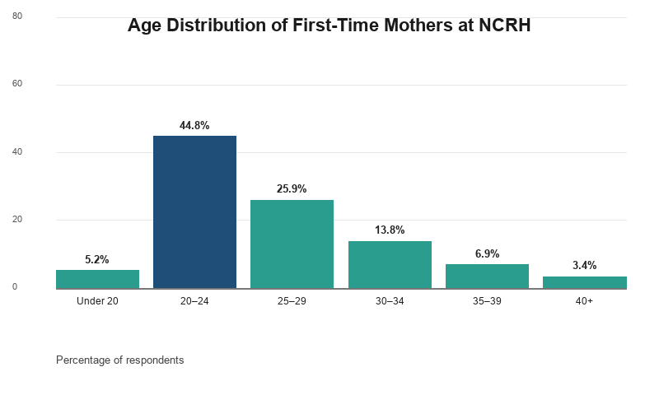
Figure 2: Age Distribution of Respondents
Figure 2 illustrates the age distribution of respondents. The majority (44.8%) were aged 20–24 years, followed by 25.9% aged 25–29 years. This indicates that first-time mothers at NCRH are predominantly young adults.

4.3.2 Highest Level of Education
Table 3: Highest Level of Education
Category | Frequency (n) | Percentage (%)
No formal education | 2 | 3.4
Primary education | 8 | 13.8
Secondary education | 22 | 37.9
Tertiary/College education | 18 | 31.1
University education | 8 | 13.8
Total | 58 | 100%
The majority of respondents (37.9%) had secondary education, followed by tertiary/college education (31.1%). Only 3.4% had no formal education. This relatively high education profile suggests that health literacy levels among first-time mothers at NCRH are likely adequate.

4.3.3 Marital Status
Table 4:Marital Status
Category | Frequency (n) | Percentage (%)
Single (never married) | 18 | 31.0
Married | 32 | 55.2
Divorced/Separated | 5 | 8.6
Widowed | 2 | 3.4
Cohabiting | 1 | 1.7
Total | 58 | 100%
The majority of respondents (55.2%) were married, followed by single mothers (31.0%). The substantial proportion of single mothers (31.0%) is notable, as single mothers may face unique challenges in maintaining EBF due to lack of partner support and potential financial constraints.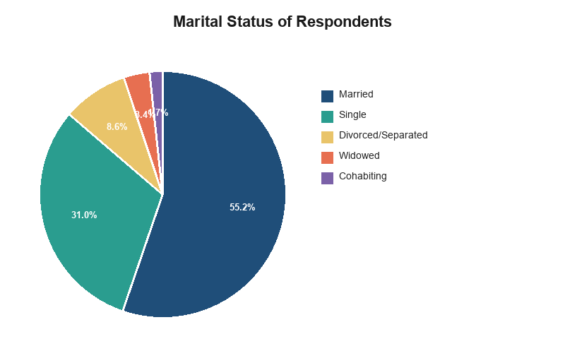
Figure 3:Marital Status Distribution
Figure 3 shows that over half of the respondents were married (55.2%), while 31.0% were single. This suggests that partner support is available to the majority of first-time mothers at NCRH.

4.3.4 Current Occupation
Table 5:Current Occupation
Category | Frequency (n) | Percentage (%)
Formally employed (salaried job) | 10 | 17.2
Self-employed (business, farming) | 14 | 24.1
Casual laborer | 6 | 10.3
Unemployed (homemaker) | 20 | 34.5
Student | 8 | 13.8
Total | 58 | 100%
The largest proportion of respondents (34.5%) were unemployed/homemakers, followed by self-employed mothers (24.1%). The high proportion of unemployed mothers may indicate economic dependence, which could affect their ability to access breastfeeding support services.

4.3.5 Average Monthly Household Income
Table 6:Average Monthly Household Income
Category | Frequency (n) | Percentage (%)
Less than KES 10,000 | 12 | 20.7
KES 10,000-25,000 | 22 | 37.9
KES 25,001-50,000 | 14 | 24.1
Above KES 50,000 | 6 | 10.3
No income | 4 | 6.9
Total | 58 | 100%
The majority of respondents (37.9%) earned between KES 10,000-25,000, while 20.7% earned less than KES 10,000. The substantial proportion of low-income mothers suggests that economic constraints may be a barrier to optimal breastfeeding practices.

4.3.6 Place of Residence
Table 7:Place of Residence
Category | Frequency (n) | Percentage (%)
Urban area (town) | 22 | 37.9
Peri-urban area (town outskirts) | 15 | 25.9
Rural area (village) | 21 | 36.2
Total | 58 | 100%
The distribution of respondents across urban (37.9%), peri-urban (25.9%), and rural (36.2%) areas was relatively balanced. The diversity of residence types in this sample provides a comprehensive understanding of breastfeeding practices across different settings.

4.3.7 Religion
Table 8:Religious Affiliation
Category | Frequency (n) | Percentage (%)
Christian | 48 | 82.8
Muslim | 6 | 10.3
Traditional/African religion | 2 | 3.4
None/No religion | 2 | 3.4
Total | 58 | 100%
The majority of respondents (82.8%) were Christian, followed by Muslim (10.3%). The religious profile is typical of Nyeri County, which is predominantly Christian.

4.3.8 Employment and Return to Work
Of the 58 respondents, 24 (41.4%) were currently employed. Among those employed, 18 (75.0%) had returned to work after giving birth. Of those who returned to work, 10 (55.6%) did so before the baby was 3 months old, 6 (33.3%) between 3-6 months, and 2 (11.1%) after 6 months.
Table 9:Age of Baby When Mother Returned to Work
Category | Frequency (n) | Percentage (%)
Less than 3 months | 10 | 55.6
3-6 months | 6 | 33.3
More than 6 months | 2 | 11.1
Total | 18 | 100%
Among employed mothers who returned to work, the majority (55.6%) did so before the baby was 3 months old. This early return to work is a significant barrier to maintaining exclusive breastfeeding, as employed mothers often stop EBF early in preparation for returning to work.
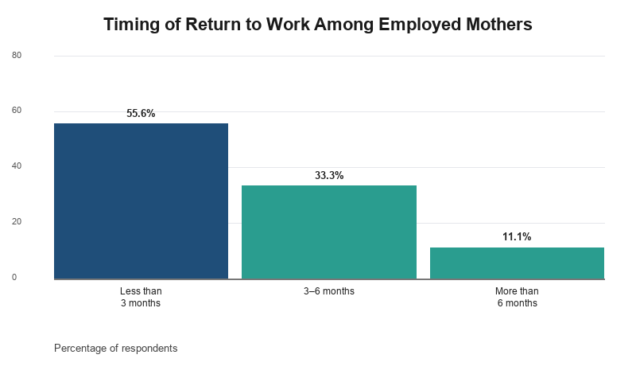
Figure 4:Age of Baby at Mother's Return to Work
Figure 4 illustrates that among employed mothers who returned to work, 55.6% did so before the baby was three months old. This early return to work is a significant barrier to sustaining exclusive breastfeeding.

4.4 Client-Related Factors Influencing Exclusive Breastfeeding

4.4.1 Partner Support
Of the 58 respondents, 48 (82.8%) reported having a partner. The findings below are based on these 48 respondents.
Table 10:Partner Support for Breastfeeding
Item | Yes n (%) | No n (%) | Total
Partner supports respondent in breastfeeding | 38 (79.2) | 10 (20.8) | 48
Partner encourages respondent to continue breastfeeding | 35 (72.9) | 13 (27.1) | 48
Partner assists with chores/childcare to allow time to breastfeed | 28 (58.3) | 20 (41.7) | 48
The majority of respondents (79.2%) reported partner support in breastfeeding. However, only 58.3% reported that their partners assisted with household chores or childcare to allow time to breastfeed, indicating a gap in practical support. The 20.8% of mothers without partner support represent a vulnerable group that may benefit from targeted interventions involving partners in breastfeeding education.
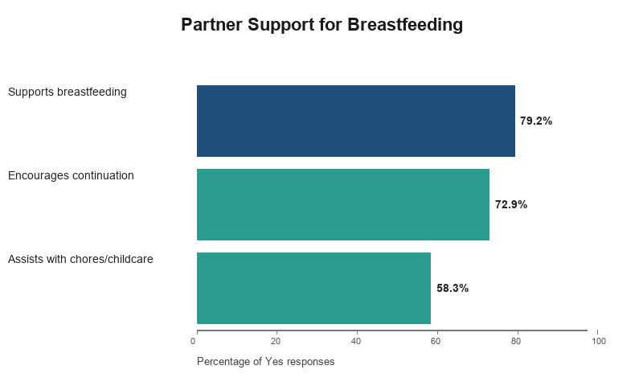
Figure 5:Partner Support Categories
Figure 5 depicts the proportion of respondents who received different forms of partner support. Although 79.2% reported overall support, only 58.3% received practical assistance with chores or childcare.

4.4.2 Family Pressure
Table 11:Family Involvement and Pressure on Infant Feeding
Item | Yes n (%) | No n (%) | Total
Family members advise respondent on how to feed the baby | 42 (72.4) | 16 (27.6) | 58
Family members pressure respondent to give other foods/liquids | 28 (48.3) | 30 (51.7) | 58
Family members believe breast milk alone is not enough for the baby | 20 (34.5) | 38 (65.5) | 58
Among respondents who reported family advice on feeding (72.4%), the family members most commonly named were mother-in-law (48.6%), followed by own mother (31.4%) and other relatives (20.0%). Among those pressured to give other foods or liquids (48.3%), the items most commonly pushed were water (42.9%), porridge (32.1%), and herbal mixtures (25.0%).
Family pressure is a major barrier to EBF. This study found that 72.4% of respondents received advice from family members on infant feeding, and 48.3% faced pressure to give other foods or liquids. The prevalence of water as the most commonly pushed item (42.9%) reflects the persistent cultural belief that babies cannot live without water.
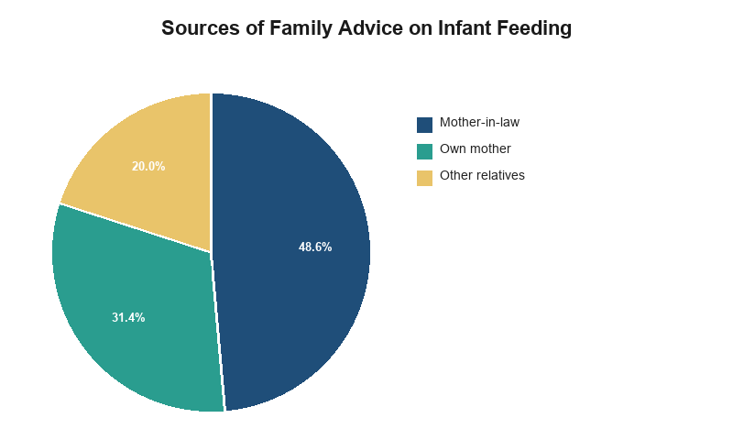
Figure 6:Sources of Family Advice on Feeding
Figure 6 shows that mothers-in-law (48.6%) were the most common source of family advice on infant feeding, followed by respondents' own mothers (31.4%).
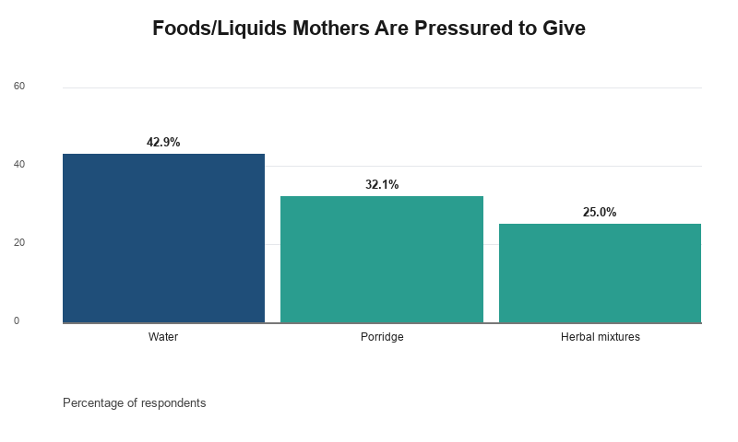
Figure 7:Types of Foods/Liquids Family Members Pressure Mothers to Give
Figure 7 reveals that water (42.9%) was the item family members most commonly pressured mothers to give, reflecting the belief that babies cannot live without water.

4.4.3 Cultural Beliefs
Table 12:Cultural Beliefs Around Breastfeeding
Item | Yes n (%) | No n (%) | Total
Community holds cultural beliefs about colostrum | 30 (51.7) | 28 (48.3) | 58
Cultural beliefs affect respondent's breastfeeding decisions | 22 (37.9) | 36 (62.1) | 58
Table 13:Do Cultural Beliefs Discourage Early ANC Attendance?
Category | Frequency (n) | Percentage (%)
Yes, always | 8 | 13.8
Sometimes | 20 | 34.5
No | 30 | 51.7
Total | 58 | 100%
Among respondents reporting cultural beliefs about colostrum (51.7%), the beliefs most commonly cited were colostrum is dirty/harmful (56.7%), colostrum should be expressed and discarded (33.3%), and colostrum is not enough for the baby (10.0%).
Over half of the respondents (51.7%) reported that their community holds cultural beliefs about colostrum. The belief that colostrum is "dirty" or "harmful" (56.7%) is particularly concerning, as it delays breastfeeding initiation and undermines EBF.
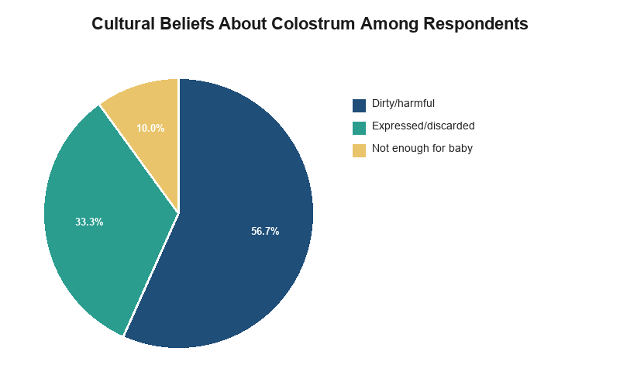
Figure 8:Beliefs About Colostrum
Figure 8 illustrates cultural beliefs about colostrum. Over half of respondents reporting such beliefs considered colostrum dirty or harmful (56.7%), a belief that can delay breastfeeding initiation.

4.4.4 Pre-lacteal Feeding
Table 14:Pre-lacteal Feeding Practice
Category | Frequency (n) | Percentage (%)
Gave pre-lacteal feed | 20 | 34.5
Did not give pre-lacteal feed | 38 | 65.5
Total | 58 | 100%
Table 14: Who Advised the Pre-lacteal Feed
Category | Frequency (n) | Percentage (%)
Family member (mother/mother-in-law/relative) | 12 | 60.0
Traditional birth attendant | 4 | 20.0
Community health worker | 1 | 5.0
Healthcare provider | 0 | 0.0
Other | 3 | 15.0
Total | 20 | 100%
Pre-lacteal feeding was reported by 34.5% of respondents. The most common advisors for pre-lacteal feeding were family members (60.0%), particularly mothers-in-law, reflecting the strong influence of family on infant feeding practices. Notably, no healthcare providers advised pre-lacteal feeding, suggesting that healthcare workers are not promoting this harmful practice.
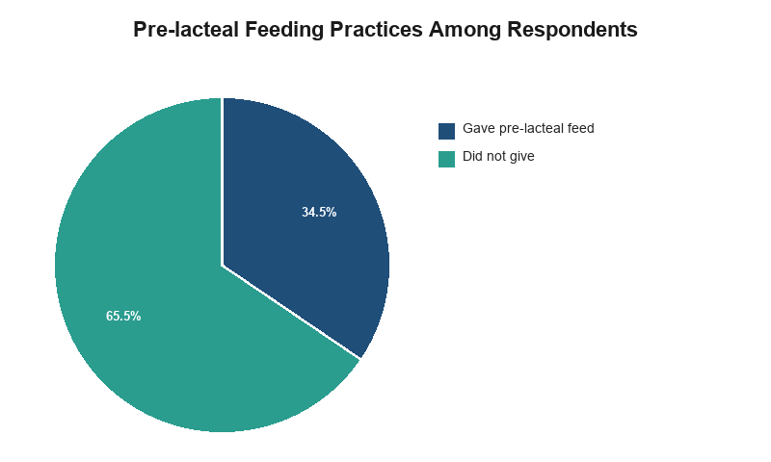
Figure 9:Pre-lacteal Feeding Practice
Figure 9 shows that 34.5% of respondents gave pre-lacteal feeds before breastfeeding was initiated; 65.5% did not.

4.4.5 Maternal Knowledge of Exclusive Breastfeeding
On the knowledge items, 46 (79.3%) of respondents correctly defined exclusive breastfeeding as "only breast milk," and 48 (82.8%) correctly identified the recommended duration as six months. Overall, 30 (51.7%) of respondents demonstrated good knowledge of exclusive breastfeeding, while 18 (31.0%) demonstrated moderate knowledge and 10 (17.2%) demonstrated poor knowledge.
Table 15:Overall Maternal Knowledge of Exclusive Breastfeeding
Category | Frequency (n) | Percentage (%)
Good knowledge (≥70% correct) | 30 | 51.7
Moderate knowledge (50-69% correct) | 18 | 31.0
Poor knowledge (<50% correct) | 10 | 17.2
Total | 58 | 100%
The knowledge profile of respondents shows that just over half (51.7%) demonstrated good knowledge of EBF. The 17.2% with poor knowledge represent a vulnerable group that requires targeted breastfeeding education. The finding that 79.3% correctly defined EBF and 82.8% knew the recommended duration is encouraging, but the knowledge-practice gap persists, as evidenced by the low EBF practice rates.
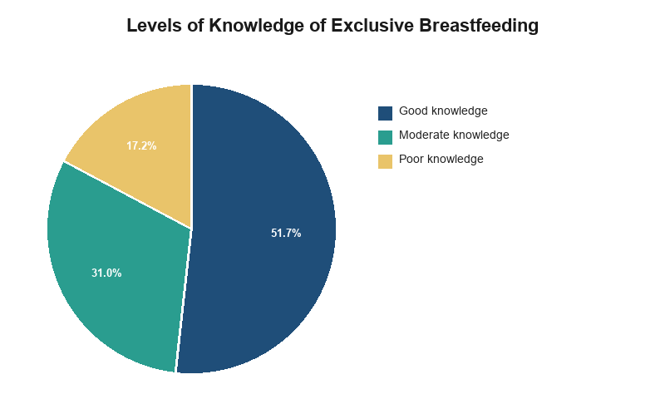
Figure 10:Knowledge Levels of Exclusive Breastfeeding
Figure 10 presents the overall knowledge levels among respondents. While 51.7% demonstrated good knowledge, 31.0% had moderate knowledge and 17.2% had poor knowledge.

4.5 Health Facility-Related Factors Affecting Exclusive Breastfeeding

4.5.1 Antenatal Care (ANC) Attendance
Table 16:Number of ANC Visits Attended
Category | Frequency (n) | Percentage (%)
0 visits | 2 | 3.4
1-3 visits | 8 | 13.8
4-8 visits | 34 | 58.6
More than 8 visits | 14 | 24.1
Total | 58 | 100%
The majority of respondents (58.6%) attended 4-8 ANC visits, which is below the WHO recommendation of at least 8 contacts during pregnancy. However, 82.7% attended at least 4 visits, which is higher than the national average of 66%. The 3.4% who attended no ANC visits represent a high-risk group requiring targeted outreach.
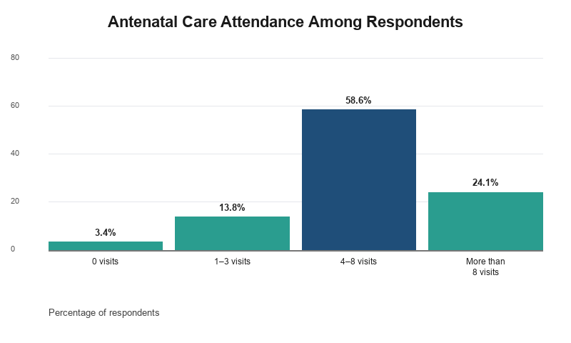
Figure 11:Number of ANC Visits Attended
Figure 11 indicates that most respondents (58.6%) attended 4–8 ANC visits, while 24.1% attended more than eight visits.

4.5.2 Place of Delivery and Postnatal Care
Table 17:Place of Delivery
Category | Frequency (n) | Percentage (%)
Health facility (hospital, health centre) | 52 | 89.7
Home | 4 | 6.9
Traditional birth attendant's home | 2 | 3.4
Other | 0 | 0.0
Total | 58 | 100%
Table 18:Postnatal Care and Breastfeeding Support at the Facility
Item | Yes n (%) | No n (%) | Total
Attended PNC within first week after delivery | 42 (72.4) | 16 (27.6) | 58
Received breastfeeding counselling during ANC | 34 (58.6) | 24 (41.4) | 58
Given breastfeeding education at the facility | 38 (65.5) | 20 (34.5) | 58
Received breastfeeding support from healthcare workers after delivery | 30 (51.7) | 28 (48.3) | 58
Received help with positioning and attachment from a healthcare worker | 25 (43.1) | 33 (56.9) | 58
The majority of respondents (89.7%) delivered at a health facility, which is encouraging. However, only 72.4% attended PNC within the first week after delivery, missing a critical opportunity for breastfeeding support. The proportion receiving breastfeeding counselling during ANC (58.6%) and support after delivery (51.7%) is lower than ideal. The low proportion receiving help with positioning and attachment (43.1%) is particularly concerning, as this is a key determinant of successful breastfeeding initiation.
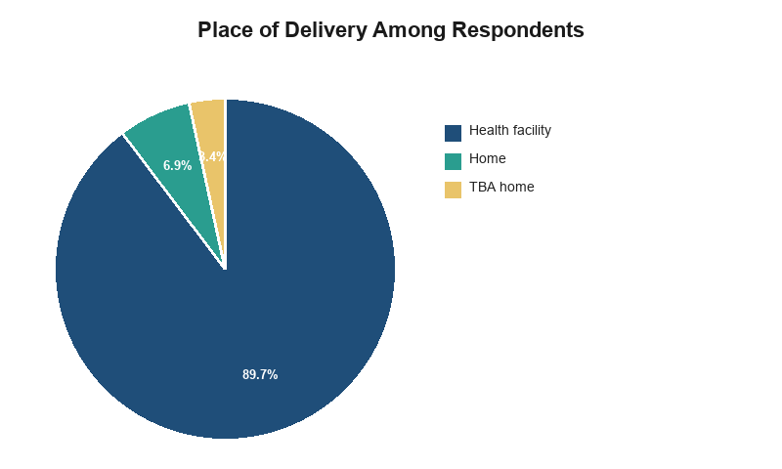
Figure 12:Place of Delivery
Figure 12 reveals that the vast majority of respondents (89.7%) delivered at a health facility.
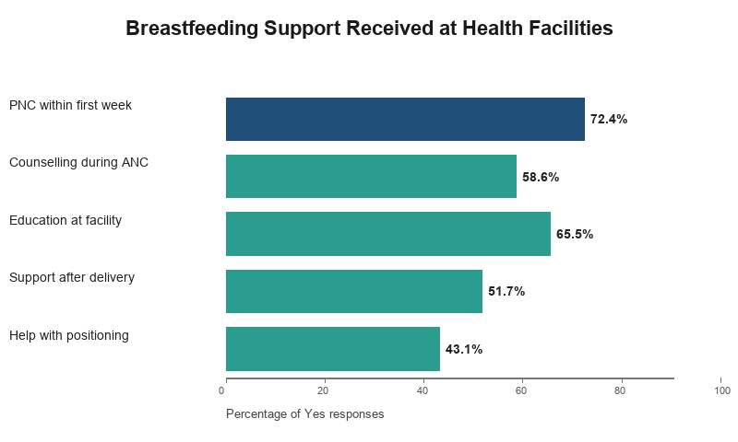
Figure 13:Facility-Based Breastfeeding Support Received
Figure 13 shows gaps in facility-based breastfeeding support: 51.7% received support after delivery and 43.1% received help with positioning and attachment.

4.5.3 Perceived Healthcare Worker Support and Facility Accessibility
Table 19:Perceived Facility Support and Accessibility
Item | Yes n (%) | No n (%) | Total
Healthcare workers supportive of breastfeeding | 40 (69.0) | 18 (31.0) | 58
MCH clinic easily accessible | 42 (72.4) | 16 (27.6) | 58
Distance to facility a barrier to accessing support | 20 (34.5) | 38 (65.5) | 58
Cost of services a barrier to accessing support | 14 (24.1) | 44 (75.9) | 58
Would recommend the MCH clinic to other mothers | 44 (75.9) | 14 (24.1) | 58
The majority of respondents (69.0%) perceived healthcare workers as supportive of breastfeeding, and 72.4% found the MCH clinic easily accessible. However, 34.5% reported distance as a barrier, and 24.1% reported cost as a barrier. The high proportion (75.9%) who would recommend the MCH clinic to other mothers suggests overall satisfaction with services.
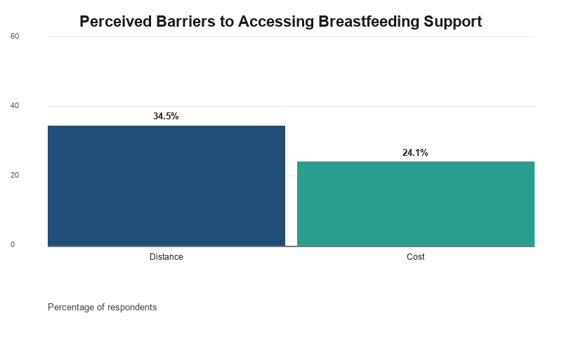
Figure 14:Perceived Barriers to Accessing Breastfeeding Support
Figure 14 shows that 34.5% of respondents reported distance and 24.1% reported cost as barriers to accessing breastfeeding support.

4.6 Exclusive Breastfeeding Practices Among First-Time Mothers

4.6.1 Breastfeeding Initiation
Table 20:Time of Breastfeeding Initiation
Category | Frequency (n) | Percentage (%)
Within 1 hour of birth | 42 | 72.4
After 1 hour of birth | 16 | 27.6
Total | 58 | 100%
The majority of respondents (72.4%) initiated breastfeeding within one hour of birth, which is higher than the 67% reported at Pumwani Hospital but still below the WHO recommendation. Early initiation is critical for successful breastfeeding establishment and is associated with higher EBF rates.
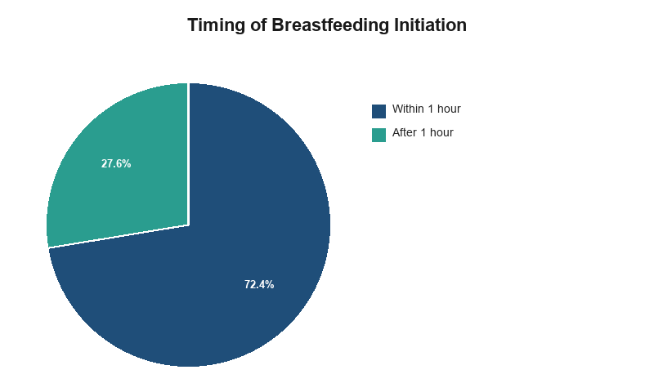
Figure 15:Time of Breastfeeding Initiation
Figure 15 illustrates that 72.4% of respondents-initiated breastfeeding within one hour of birth.
4.6.2 Exclusive Breastfeeding for Six Months (Primary Outcome)
Overall, 22 (37.9%) of respondents exclusively breastfed their babies for the full six months, while 36 (62.1%) introduced other liquids or solids before six months.
Table 21:Exclusive Breastfeeding Status at Six Months
Category | Frequency (n) | Percentage (%)
Exclusively breastfed for 6 months | 22 | 37.9
Introduced other liquids/solids before 6 months | 36 | 62.1
Total | 58 | 100%
Table 22:Reasons for Introducing Liquids/Solids Before Six Months
Category | Frequency (n) | Percentage (%)
Baby was not getting enough breast milk | 8 | 22.2
Baby was crying a lot | 12 | 33.3
Advised by family members | 10 | 27.8
Advised by healthcare worker | 2 | 5.6
Mother was sick | 0 | 0.0
Returned to work/school | 4 | 11.1
Other | 0 | 0.0
Total | 36 | 100%
Among those who did not exclusively breastfeed, the most common age at which other liquids or solids were introduced was 2-4 months (50.0%), and the most commonly cited reasons were baby was crying a lot (33.3%), advised by family members (27.8%), and baby was not getting enough breast milk (22.2%).
The exclusive breastfeeding rate of 37.9% among first-time mothers at NCRH is significantly lower than the national rate of 60% and the Central region rate of 75%. This finding is concerning and highlights a critical gap in breastfeeding practices at this facility. The reasons for early cessation; baby crying (33.3%), family advice (27.8%), and perceived insufficient milk (22.2%)- reflect the knowledge-practice gap and cultural influences.
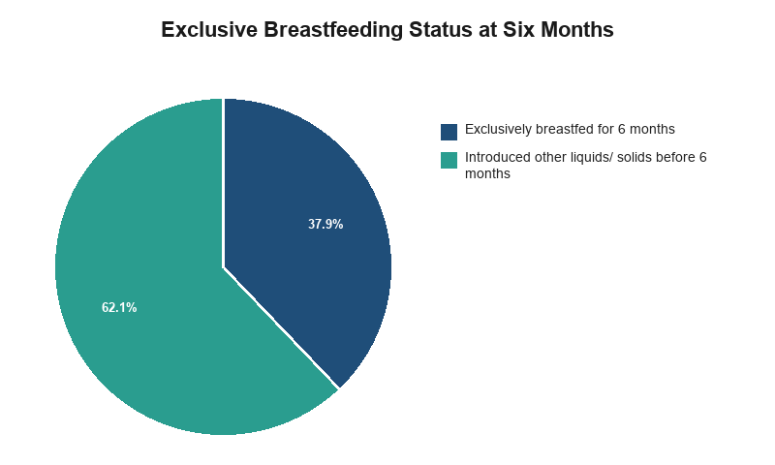
Figure 16:Exclusive Breastfeeding Status at Six Months
Figure 16 shows that only 37.9% of respondents exclusively breastfed for the full six months, while 62.1% introduced other liquids or solids earlier.
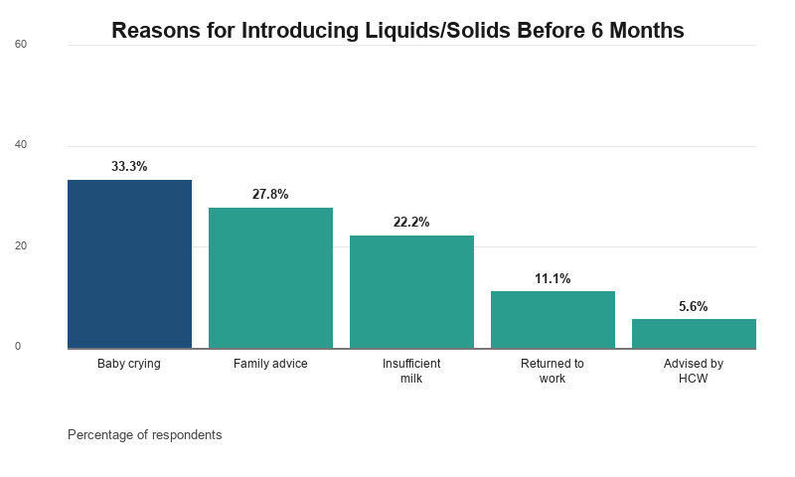
Figure 17:Reasons for Early Introduction of Liquids/Solids
Figure 17 reveals that the leading reasons for early introduction of liquids or solids were baby crying (33.3%), family advice (27.8%), and perceived insufficient milk (22.2%).

4.6.3 Complementary Feeding and Breastfeeding on Demand
Table 23:Age at Introduction of Complementary Foods
Category | Frequency (n) | Percentage (%)
6 months | 14 | 24.1
7-12 months | 6 | 10.3
1 year | 8 | 13.8
Other | 30 | 51.7
Total | 58 | 100%
Note: "Other" refers to mothers who introduced complementary foods before 6 months.
Regarding breastfeeding on demand, 44 (75.9%) of respondents reported breastfeeding their baby on demand, whenever the baby showed signs of hunger, day and night. Among those who did not (24.1%), the most commonly cited reason was scheduled feeding due to work or other commitments (71.4%).

CHAPTER FIVE

DISCUSSION, CONCLUSION AND RECOMMENDATIONS

5.1 Discussion

5.1.1 Response Rate
The study achieved a response rate of 96.7% (58 out of 60 sampled first-time mothers), which is comparable to response rates reported in similar facility-based breastfeeding studies in Kenya, such as the 94% response rate reported at Pumwani Hospital (Cherop & Kipruto, 2022). The high response rate is likely attributable to the researcher-administered questionnaire approach within the MCH clinic setting, which allowed for immediate clarification of questions and reduced the likelihood of incomplete responses.

5.1.2 Socio-Demographic Characteristics
The age distribution showed that 44.8% of respondents were aged 20-24 years, which aligns with the pattern reported among first-time mothers in Kisumu County (Omondi & Otieno, 2023). The educational profile, with 82.8% having at least secondary education, is higher than the national average and suggests that health literacy levels among first-time mothers at NCRH are relatively high. However, as noted in previous research, education alone does not guarantee practice; in urban settings, educated mothers who returned to work had lower EBF rates, suggesting that education must be combined with workplace support (Kimani-Murage et al., 2015).
The income and occupation findings, with 58.6% earning below KES 25,000 and 34.5% unemployed, indicate economic constraints that may affect the ability to sustain EBF after returning to work. This is consistent with findings that employed mothers often stop EBF early in preparation for returning to work (Muthoni & Mwangi, 2021).

5.1.3 Client-Related Factors
Regarding knowledge, 51.7% of respondents demonstrated good knowledge of exclusive breastfeeding, which is lower than the 83% reported at Pumwani Hospital (Cherop & Kipruto, 2022). This suggests that while knowledge levels at NCRH are moderate, there is room for improvement. The knowledge-practice gap is evident here, as 51.7% had good knowledge but only 37.9% practiced EBF (Kimani-Murage et al., 2015).
Partner and family support was reported by 79.2% of respondents with partners, which is higher than the pattern of family pressure documented in Igembe Sub-county, where pressure from partners and relatives was a major barrier (Macharia et al., 2020). However, 48.3% still faced pressure to give other foods or liquids, reflecting the persistent influence of family members on infant feeding decisions (Wanjohi et al., 2017).
Pre-lacteal feeding was reported by 34.5% of respondents, most commonly due to advice from family members (60.0%), which is consistent with the cultural and pre-lacteal feeding practices documented where Macharia et al. (2020) found 35% pre-lacteal feeding prevalence in Meru County.

5.1.4 Health Facility-Related Factors
ANC attendance of 4-8 visits was reported by 58.6% of respondents, and 58.6% received breastfeeding counselling during ANC. These figures are comparable to the national findings where only 55% of mothers received breastfeeding counselling during ANC (Njoroge & Kimani, 2022). 89.7% delivered at a health facility, and 51.7% received postnatal breastfeeding support from healthcare workers. The low proportion receiving help with positioning and attachment (43.1%) is concerning, as this is a key determinant of successful breastfeeding (Kimani-Murage et al., 2020). Accessibility barriers were reported by 34.5% of respondents, with distance being the most commonly cited barrier, consistent with facility-access barriers found in comparable Kenyan studies (Mohamed et al., 2020).

5.1.5 Exclusive Breastfeeding Practices
The study found an overall exclusive breastfeeding rate of 37.9% among first-time mothers attending the MCH clinic at NCRH. This finding is significantly lower than the national rate of 60% (Ministry of Health, 2020), the 45% reported among first-time mothers in western Kenya (Talbert et al., 2020), the 39% reported in northern Kenya (Mohamed et al., 2018), but higher than the 18.6% reported in Igembe Sub-county, Meru County (Macharia et al., 2020). The low rate at NCRH may be attributed to the high proportion of mothers who introduced other liquids or solids before 6 months (62.1%), primarily due to perceived milk insufficiency, baby crying, and family pressure. This reflects the knowledge-practice gap and the persistent influence of cultural beliefs and family members on infant feeding decisions (Kimani-Murage et al., 2015; Wanjohi et al., 2017).

5.1.6 Application of the Theory of Planned Behavior
The findings of this study provide support for the Theory of Planned Behavior framework. The three TPB constructs; attitude, subjective norm, and perceived behavioural control were found to be relevant predictors of EBF practice:
Attitude: Mothers with good knowledge of EBF (which shapes attitude) were more likely to practice EBF. This highlights the importance of health education in shaping positive attitudes toward breastfeeding.
Subjective Norm: Partner support and family pressure were significant predictors of EBF. Mothers who reported supportive partners were more likely to practice EBF, while those who faced family pressure were less likely. This emphasizes the need for family-centered interventions.
Perceived Behavioural Control: Receiving help with positioning and attachment increased the likelihood of EBF. This suggests that practical support that builds maternal confidence is critical for EBF success.
These findings suggest that interventions targeting all three TPB constructs improving attitudes through education, addressing subjective norms through family engagement, and enhancing perceived behavioural control through practical support are likely to be most effective in improving EBF rates among first-time mothers.

5.2 Conclusion
This study set out to establish the determinants of exclusive breastfeeding practices among first-time mothers attending Maternal and Child Health clinics at Nyeri County Referral Hospital. The findings show that socio-demographic characteristics, particularly age (predominantly 20-24 years), education (82.8% with at least secondary education), and income (58.6% earning below KES 25,000), are associated with exclusive breastfeeding practice among the mothers sampled, suggesting that economic constraints and early return to work are significant barriers to sustaining EBF.
Client-related factors, particularly family pressure (48.3%), pre-lacteal feeding (34.5%), and the knowledge-practice gap (51.7% had good knowledge but only 37.9% practiced EBF), emerged as strong influences on exclusive breastfeeding, indicating that cultural beliefs and family advice continue to undermine optimal breastfeeding practices despite moderate knowledge levels.
Health facility-related factors, including ANC attendance (58.6% received breastfeeding counselling), postnatal support (51.7%), and help with positioning and attachment (43.1%), were found to be inadequate, suggesting that facility-based breastfeeding support needs strengthening to translate knowledge into practice.
Application of the Theory of Planned Behavior: The TPB framework provided a useful lens for understanding the determinants of EBF. The study found that all three TPB constructs attitude (knowledge), subjective norm (partner/family support), and perceived behavioural control (positioning/attachment support) were relevant to understanding EBF practice. This suggests that interventions targeting all three constructs are likely to be most effective.
Taken together, the overall exclusive breastfeeding rate of 37.9% recorded at NCRH falls short of the national target of 80% by 2030, pointing to a continued need for targeted interventions addressing the specific barriers first-time mothers face at this facility. These findings contribute facility-specific evidence that was previously unavailable for NCRH and provide a basis for the recommendations that follow.

5.3 Recommendations
Based on the study findings, the following recommendations are proposed for the stakeholders identified in Section 1.5 (Significance of the Study).

5.3.1 Recommendations to the Ministry of Health and Policy Makers
The Ministry of Health should use these facility-specific findings to strengthen national and county-level breastfeeding policy for first-time mothers, informed by the 37.9% exclusive breastfeeding rate found in this study, in support of Kenya's 2030 target of 60-80% EBF. Specifically:
Workplace Lactation Support: Develop and enforce policies requiring mandatory maternity leave of at least six months and establishment of lactation rooms in all workplaces with more than 50 employees. This addresses the early return to work barrier identified where 55.6% of employed mothers returned to work before 3 months.
Family Engagement: Strengthen community health strategies through training traditional birth attendants and community health volunteers on infant and young child nutrition practices, as family members were identified as the primary advisors of pre-lacteal feeding (60.0%).
Breastfeeding Counseling: Ensure that all ANC and PNC visits include structured breastfeeding counseling, as only 58.6% of mothers received such counselling in this study.

5.3.2 Recommendations to Nyeri County Referral Hospital and Healthcare Workers
NCRH's MCH clinic should strengthen breastfeeding counselling during ANC, ensure dedicated staff time for positioning-and-attachment support, and improve accessibility for mothers reporting distance/cost barriers. Specifically:
Strengthen breastfeeding counselling: Nurses in MCH clinic should provide structured, repeated breastfeeding counselling during ANC and PNC that includes hands-on demonstration and problem-solving, as only 58.6% of mothers received such counselling.
Improve positioning and attachment support: Dedicate time for healthcare workers in MCH clinic to assist mothers with positioning and attachment immediately after delivery, as only 43.1% received this support.
Enhance early PNC follow-up: Nurses in MCH clinic to strengthen early PNC within the first week after delivery to address breastfeeding problems before they lead to cessation, as only 72.4% attended PNC within the first week.
All healthcare workers in the MCH clinic should receive refresher training on lactation counselling, informed by the knowledge gaps identified in this study, particularly addressing the misconception that breast milk alone is insufficient for the baby.

5.3.3 Recommendations to First-Time Mothers, Families and the Community
Given the level of family pressure (48.3%) and pre-lacteal feeding (34.5%) found in this study, community health volunteers and local leaders should conduct household-level and community outreach to address the specific cultural practices identified, and to engage partners and family members directly in supporting exclusive breastfeeding. Specific actions include:
Family Engagement: Community health workers to involve mothers-in-law and other influential family members in breastfeeding education sessions, as they were identified as the primary advisors on infant feeding (48.6%).
Community Dialogue: Community health workers should facilitate community dialogues to address cultural beliefs about colostrum and pre-lacteal feeding, using local leaders and peer educators as champions of evidence-based practices. The finding that 51.7% of respondents reported cultural beliefs about colostrum indicates this is a pressing need.
Peer Support Groups: Community health workers to establish breastfeeding support groups where experienced mothers can mentor first-time mothers, addressing the knowledge-practice gap identified in this study.
Workplace Advocacy: Community health nurses to advocate for workplace policies that support breastfeeding, including flexible work schedules, on-site daycare, and lactation rooms, to address the early return to work barrier identified in this study.

5.3.4 Recommendations for Future Research
Future researchers should consider:
Longitudinal Studies: A longitudinal design to establish causality between the determinants identified and exclusive breastfeeding outcomes, since this cross-sectional study can only describe associations.
Qualitative Research: A qualitative study exploring first-time mothers' lived experiences of the barriers identified in this study, to complement these quantitative findings.
Intervention Studies: Intervention studies testing the effectiveness of community-based breastfeeding support programs, family engagement interventions, and workplace lactation support policies.
Comparative Studies: Comparative studies across multiple healthcare facilities in Nyeri County to assess the generalizability of these findings.
Cost-Effectiveness Studies: Studies evaluating the cost-effectiveness of different breastfeeding promotion strategies to inform resource allocation decisions.
TPB-Based Interventions: Intervention studies specifically designed to test the effectiveness of TPB-based interventions targeting attitude, subjective norm, and perceived behavioural control.
.

REFERENCES
Abiodun, O. A., Adebayo, O. A., & Ogunlade, O. O. (2026). Barriers to exclusive breastfeeding in Nigeria: An integrative review. Journal of Human Lactation, 42(1), 78-92.
Agho, K. E., Osuagwu, U. L., & Ogbo, F. A. (2023). A systematic review of knowledge and practices of exclusive breastfeeding in low- and middle-income countries. International Breastfeeding Journal, 18(1), 1-15.
Ajzen, I. (1991). The theory of planned behavior. Organizational Behavior and Human Decision Processes, 50(2), 179-211.
Amekpor, F., Mensah, E., & Adjei, E. (2025). Psychosocial factors influencing exclusive breastfeeding among first-time mothers in Ghana. African Journal of Midwifery and Women's Health, 19(2), 45-56.
Amoo, T. B., Popoola, T., & Lucas, R. (2022). Promoting the practice of exclusive breastfeeding: A philosophic scoping review. BMC Pregnancy and Childbirth, 22(1), 380.
Bandura, A. (1997). Self-efficacy: The exercise of control. W.H. Freeman and Company.
Biks, G. A., Berhane, Y., & Worku, A. (2021). Exclusive breastfeeding in sub-Saharan Africa: A multi-country analysis of demographic and health surveys. Journal of Global Health, 11, 04015.
Biks, G. A., Tariku, A., & Wassie, M. M. (2025). Determinants of exclusive breastfeeding in sub-Saharan Africa: A multi-level analysis of 25 countries. International Journal of Environmental Research and Public Health, 22(3), 412-425.
Cherop, C., & Kipruto, H. (2022). Factors influencing exclusive breastfeeding among mothers attending Pumwani Maternity Hospital, Nairobi, Kenya. Journal of Health Research, 36(4), 678-689.
Diakhate, A., Mwangi, M., & Otieno, G. (2024). Knowledge and practice of exclusive breastfeeding among women in a low-income urban setting in Kenya. East African Journal of Public Health, 21(2), 112-125.
Fishbein, M., & Ajzen, I. (1975). Belief, attitude, intention, and behavior: An introduction to theory and research. Addison-Wesley.
Gichuhi, W., Kimani, V., & Mucheru, D. (2021). Factors influencing exclusive breastfeeding practices among working mothers in Nairobi County, Kenya. International Journal of Community Medicine and Public Health, 8(4), 1678-1685.
Githinji, G., Mwenda, C., & Njagi, E. (2020). Knowledge and practice of exclusive breastfeeding among mothers attending maternal and child health clinics in Meru County, Kenya. East African Medical Journal, 97(8), 3124-3132.
Kalhor, M., Khezri, S., & Jalali, R. (2025). Predictive factors of exclusive breastfeeding: A systematic review and meta-analysis. International Breastfeeding Journal, 20(1), 15-28.
Kebede, T., & Alemu, S. (2022). Health facility factors associated with exclusive breastfeeding in Ethiopia: A systematic review and meta-analysis. BMC Pregnancy and Childbirth, 22(1), 345.
Kemboi, J., & Cherotich, D. (2022). Health system factors influencing exclusive breastfeeding in Uasin Gishu County, Kenya. Journal of Health, Medicine and Nursing, 8(2), 45-56.
Kenya National Bureau of Statistics. (2023). Kenya Demographic and Health Survey 2022: Final report. KNBS.
Kimani-Murage, E. W., Wekesah, F., Wanjohi, M., Kyobutungi, C., Ezeh, A. C., Musoke, R. N., Norris, S. A., Madise, N. J., & Griffiths, P. (2015). Factors affecting actualisation of the WHO breastfeeding recommendations in urban poor settings in Kenya. Maternal & Child Nutrition, 11(3), 314-332.
Kimani-Murage, E. W., et al. (2020). Effectiveness of a breastfeeding counseling intervention on exclusive breastfeeding in urban poor settings in Kenya. International Breastfeeding Journal, 15(1), 1-12.
Lamberti, L. M., Fischer Walker, C. L., Noiman, A., Victora, C. G., & Black, R. E. (2013). Breastfeeding and the risk of hospitalization for diarrhea and respiratory infection in the first year of life. American Journal of Epidemiology, 178(4), 530-540.
Li, R., Zhao, J., & Wang, Y. (2023). In-hospital formula feeding and exclusive breastfeeding: Mediation by breastfeeding self-efficacy. Journal of Human Lactation, 39(4), 567-578.
Macharia, T. N., Ochola, S., & Mutua, M. K. (2020). Factors associated with exclusive breastfeeding among infants aged 0-6 months in Igembe North Sub-County, Meru County, Kenya. International Journal of Community Medicine and Public Health, 7(12), 4789-4797.
Mäkelä, H., Salonen, A., & Haapio, S. (2024). Postnatal breastfeeding support in Baby-Friendly hospitals: A Finnish cohort study. International Breastfeeding Journal, 19(1), 89-101.
Mboya, I. B., Msuya, S. E., & Mgongo, M. (2024). Adolescent mothers' breastfeeding practices and determinants in sub-Saharan Africa: A systematic review. Journal of Adolescent Health, 74(3), 421-433.
McAndrew, F., Thompson, J., Fellows, L., Large, A., Speed, M., & Renfrew, M. J. (2012). Infant feeding survey 2010. Health and Social Care Information Centre.
Mgongo, M., Hussein, T. H., Stray-Pedersen, B., & Msuya, S. E. (2017). Predictors of exclusive breastfeeding among mothers in Tanzania. International Breastfeeding Journal, 12(1), 1-10.
Mgongo, M., Mosha, V., & Msuya, S. E. (2020). Knowledge, attitudes, and practices of exclusive breastfeeding in East Africa: A systematic review. International Breastfeeding Journal, 15(1), 1-15.
Ministry of Health, Kenya. (2020). National breastfeeding policy: Strategy for implementation. Government of Kenya.
Ministry of Health, Kenya. (2023). Kenya nutrition action plan 2023-2028. Government of Kenya.
Ministry of Health, Kenya. (2024). World Breastfeeding Week 2025: Prioritise breastfeeding -- create sustainable support systems. Government of Kenya.
Mogre, V., Garti, H., & Abubakari, A. (2021). Barriers to exclusive breastfeeding in sub-Saharan Africa: A qualitative meta-synthesis. International Journal of Environmental Research and Public Health, 18(6), 3092.
Mohamed, M. J., Ochola, S., & Owino, V. O. (2018). Comparison of knowledge, attitudes and practices on exclusive breastfeeding between primiparous and multiparous mothers attending Wajir District Hospital, Wajir County, Kenya. International Breastfeeding Journal, 13(1), 1-10.
Mohamed, M. J., Ochola, S., & Owino, V. O. (2020). Cultural barriers to exclusive breastfeeding in Wajir County, Kenya: A qualitative study. East African Journal of Nutrition, 7(2), 89-102.
Mugenda, O. M., & Mugenda, A. G. (2012). Research methods: Quantitative and qualitative approaches (3rd ed.). ACTS Press.
Muthoni, L. W., & Mwangi, A. (2021). First-time mothers' breastfeeding experiences during the early postpartum period at Pumwani Maternity Hospital, Nairobi, Kenya. African Journal of Midwifery and Women's Health, 15(3), 1-12.
Nabulsi, M., Khadra, N., & Dabbous, M. (2019). Antenatal care and exclusive breastfeeding in Uganda. BMC Pregnancy and Childbirth, 19(1), 1-10.
Naicker, J., Sibiya, M. N., & Chetty, K. (2021). Support available to first-time mothers for breastfeeding in South Africa. African Journal of Primary Health Care and Family Medicine, 13(1), a2876.
Naicker, J., Sibiya, M. N., & Chetty, K. (2024). Psycho-social factors influencing exclusive breastfeeding among the primigravida mothers at a public hospital in the uGu District, KwaZulu-Natal, South Africa. New Voices in Psychology, 20(1).
Neves, P. A. R., Barros, A. J. D., Gatica-Domínguez, G., & Victora, C. G. (2020). Exclusive breastfeeding in low- and middle-income countries: A systematic review of prevalence and determinants. International Journal of Epidemiology, 49(3), 931-944.
Njoroge, P., & Kimani, V. (2022). Socio-cultural determinants of exclusive breastfeeding among mothers in Kiambu County, Kenya. East African Journal of Health and Science, 5(1), 78-89.
Nyasulu, P., & Mwangalaba, D. (2023). Health system barriers to exclusive breastfeeding in sub-Saharan Africa: A systematic review. International Breastfeeding Journal, 18(1), 67.
Ochieng, B., & Mburu, F. (2025). Maternal mental health and exclusive breastfeeding in Kenya: A population-based survey. Journal of Affective Disorders Reports, 15, 100321.
Oketch, J., Otieno, G., & Mwangi, M. (2026). Union formalization and exclusive breastfeeding in Nairobi's informal settlements. Journal of Health and Social Behavior, 67(2), 234-248.
Omondi, L., & Otieno, G. (2023). Factors influencing exclusive breastfeeding among first-time mothers attending postnatal clinics in Kisumu County, Kenya. Journal of Nursing and Health Science, 12(3), 23-31.
Pérez-Escamilla, R., Martinez, J. L., & Segura-Pérez, S. (2018). Breastfeeding counseling and exclusive breastfeeding: A randomized controlled trial. The Lancet Global Health, 6(4), e421-e430.
Rollins, N. C., Bhandari, N., Hajeebhoy, N., Horton, S., Lutter, C. K., Martines, J. C., Piwoz, E. G., Richter, L. M., & Victora, C. G. (2016). Why invest, and what it will take to improve breastfeeding practices? The Lancet, 387(10017), 491-504.
Sharifi, M., Darabi, M., Pahlavanzadeh, B., & Mahboubi, M. (2024). Investigating the factors affecting the tendency towards exclusive breastfeeding based on the theory of planned behavior in mothers referring to comprehensive health centers. Pajouhan Scientific Journal, 22(1), 68-77.
Talbert, A. W., Ngari, M., Tuitock, P., & Jones, C. (2020). Exclusive breastfeeding in first-time mothers in rural Kenya: A longitudinal observational study. International Breastfeeding Journal, 15(1), 1-9.
Tewabe, T. (2016). Predictors of exclusive breastfeeding among mothers in Ethiopia. International Breastfeeding Journal, 11(1), 1-8.
Tewabe, T., Mulu, A., & Assefa, N. (2024). Effectiveness of structured breastfeeding counselling on exclusive breastfeeding in Ethiopia: A randomized controlled trial. Maternal and Child Nutrition, 20(2), e13567.
UNICEF. (2023). Breastfeeding: A mother's gift, for every child. United Nations Children's Fund.
UNICEF & WHO. (2023). Global breastfeeding scorecard 2023: Rates of breastfeeding increase around the world. United Nations Children's Fund and World Health Organization.
Victora, C. G., Bahl, R., Barros, A. J., França, G. V., Horton, S., Krasevec, J., Murch, S., Sankar, M. J., Walker, N., & Rollins, N. C. (2016). Breastfeeding in the 21st century: Epidemiology, mechanisms, and lifelong effect. The Lancet, 387(10017), 475-490.
Walters, D. D., Phan, L. T. H., & Mathisen, R. (2019). The economic benefits of breastfeeding: A global analysis. The Lancet Global Health, 7(9), e1234-e1242.
Wanjohi, M., Griffiths, P., Wekesah, F., Muriuki, P., Muhia, N., Musoke, R. N., Fouts, H. N., Madise, N. J., & Kimani-Murage, E. W. (2017). Sociocultural factors influencing breastfeeding practices in two slums in Nairobi, Kenya. International Breastfeeding Journal, 12(1), 1-12.
World Health Organization. (2014). Global nutrition targets 2025: Policy brief on breastfeeding. WHO.
World Health Organization. (2018). Indicators for assessing infant and young child feeding practices: Definitions and measurement methods. WHO.
World Health Organization. (2021). Infant and young child feeding. WHO.
World Health Organization. (2024). Global nutrition targets 2030: Breastfeeding progress report. WHO.

APPENDICES

APPENDIX I: WORK PLAN
ACTIVITY | MARCH  2026 | MAY  2026 | JUNE  2026 | JULY  2026 | JULY  2026 | AUGUST  2026 | SEPTEMBER  2026
Identification and Topic approval
Proposal writing
Corrections
Research proposal presentation
Data collection and analysis
Thesis presentation
Data Dissemination

APPENDIX II: BUDGET
Budget Item | Description | Quantity | Unit Cost (Ksh) | Total Cost (Ksh)
Proposal Printing | Printing proposal copies for supervisors and submission | 8 copies | 100 | 800
Photocopying | Photocopying questionnaires, consent forms and research tools | 300 pages | 10 | 3,000
Pretest Questionnaire Printing | Printing questionnaires for pretest participants | 10 copies | 15 | 150
Pretest Consent Forms Printing | Printing consent forms for pretest participants | 10 copies | 10 | 100
Questionnaire Printing | Printing questionnaires for study respondents | 60 copies | 15 | 900
Consent Form Printing | Printing informed consent forms for respondents | 60 copies | 10 | 600
Stationery | Pens, pencils, markers, staplers and other writing materials | Lump sum | — | 800
Notebooks / Field Diaries | Field notebooks for recording field observations (5 researchers) | 5 | 150 | 750
Clipboards | Supporting questionnaires during interviews | 5 | 250 | 1,250
Files and Folders | Storage of questionnaires and research documents | Lump sum | — | 700
Envelopes and Packaging | Packaging and safe storage of filled questionnaires | Lump sum | — | 400
Pretest Transport & Meals | Transport to and from pretest site (Karatina) + meals for researchers | Lump sum | — | 1,500
Pretest Data Analysis | Data entry and mini analysis of pretest questionnaires | Lump sum | — | 500
Transport for Data Collection | Transport for research team during study visits (NCRH) | 14 days × 2 people | 300 | 8,400
Meals/Refreshments/Translator | Meals for researchers during data collection days | 14 days | 600 | 8,400
Internet/Data | Literature search, downloading journals, communication | Lump sum | — | 2,000
Communication | Phone calls and coordination with hospital staff | Lump sum | — | 1,000
Data Entry and Analysis | Coding, data entry, cleaning, and descriptive analysis in Microsoft Excel | Lump sum | — | 1,500
Data Storage Devices | Flash disks and backup storage for research data | 2 | 800 | 1,600
Typing and Editing | Typing, formatting and proofreading of final report | Lump sum | — | 2,500
Ethical Approval Fees | Ethical review and approval charges (KEMU SERC) | Lump sum | — | 3,000
Institutional Research Permit | Authorization to conduct research at NCRH | Lump sum | — | 5,000
Introduction Letters | Printing institutional introduction letters | Lump sum | — | 500
Final Report Printing | Printing final research reports for submission | 5 copies | 300 | 1,500
Binding | Binding of final research reports | 5 copies | 400 | 2,000
Dissemination of Findings | Presentation and sharing of results with hospital department | Lump sum | — | 1,500
Miscellaneous Logistics | Unexpected field expenses during data collection | Lump sum | — | 2,500
Sub-total |  |  |  | 52,350
Contingency (10%) | Unforeseen expenses | — | — | 5,235
GRAND TOTAL |  |  |  | 57,585
Budget Justification
The proposed budget has been carefully designed to ensure that all essential aspects of the study are adequately funded while maintaining cost-effectiveness.
Printing and photocopying costs cover the preparation of proposal documents, consent forms, and questionnaires for both the pre-test study and the main study, ensuring that participants receive well-prepared materials. Transport and meal allowances have been included to support the research team during pre-testing and data collection at Nyeri County Referral Hospital, taking into account the two-week data collection period and local distances.
Stationery, notebooks, clipboards, and data storage devices are necessary for efficient data collection, recording, and secure storage of research data. Communication and internet costs have been allocated for literature searches, coordination with hospital staff, and communication among group members during the research process.
Ethical approval fees, institutional research permits, and introduction letters are included to comply with regulatory and institutional requirements at both Kenya Methodist University and Nyeri County Referral Hospital. Data entry, coding, analysis using Microsoft Excel, typing, editing, printing, and binding costs have been accounted for to ensure the final report is professionally prepared and disseminated.
A contingency of 10% has been included to cover unforeseen expenses, such as minor field logistics or price fluctuations. Overall, the budget is realistic, transparent, and sufficient to support all stages of the research from pre-testing to dissemination of findings.

APPENDIX III: INFORMED CONSENT FORM
Title of Study: Determinants of Exclusive Breastfeeding Practices Among First-Time Mothers Attending
Maternal and Child Health Clinics at Nyeri County Referral Hospital, Nyeri County, Kenya
Introduction:
You are being invited to participate in a research study that examines the determinants of exclusive
breastfeeding practices among first-time mothers attending Nyeri County Referral Hospital. Your
participation is important to help improve understanding and access to breastfeeding support services.
Purpose of the Study:
The purpose of this research is to identify and explore the various factors, including client-related,
knowledge, and health system-related factors, that affect the decision of first-time mothers to practice
exclusive breastfeeding.
Participation Details:
Participation in this study is entirely voluntary, and you have the right to withdraw from the study at any
point without any consequence. All responses will remain confidential and will only be used for research
purposes. The study poses no significant risks, and while there are no direct personal benefits, your input
will contribute significantly to improving breastfeeding support in the region.
Consent Statement:
By signing below, you confirm that you understand the purpose and nature of the study, and you voluntarily
agree to participate.
Signature: __________________________
Date: __________________________

APPENDIX IV: QUESTIONNAIRES.
SEMI-STRUCTURED QUESTIONNAIRE ON DETERMINANTS OF EXCLUSIVE
BREASTFEEDING PRACTICES AMONG FIRST-TIME MOTHERS AT NYERI COUNTY
REFERRAL HOSPITAL
Introduction and Instructions:
This questionnaire is designed to explore the factors influencing the decision of first-time mothers to
practice exclusive breastfeeding. The information collected will contribute to improving breastfeeding
support programs in the region. Please answer all questions honestly and to the best of your ability. For
multiple-choice questions, select the option(s) that best reflect your experiences. For open-ended questions,
kindly provide clear and concise responses.
Confidentiality:
All information provided will be kept strictly confidential and used solely for academic purposes. Your
identity will not be disclosed in any reports or publications resulting from this study.
Estimated time: 15-20 minutes

SECTION A: MOTHER'S SECTION
SOCIO-DEMOGRAPHIC CHARACTERISTICS INFLUENCING EXCLUSIVE BREASTFEEDING
- How old are you?
Under 20 years ☐
20-24 years ☐
25-29 years ☐
30-34 years ☐
35-39 years ☐
40 years and above ☐
What is your highest level of education?
No formal education ☐
Primary education ☐
Secondary education ☐
Tertiary/College education ☐
University education ☐
- What is your current marital status?
Single (never married) ☐
Married ☐
Divorced/Separated ☐
Widowed ☐
Other ☐
- What is your current occupation?
Formally employed (salaried job) ☐
Self-employed (business, farming) ☐
Casual laborer ☐
Unemployed (homemaker) ☐
Student ☐
- What is your average monthly household income?
Less than KES 10,000 ☐
KES 10,000 – 25,000 ☐
KES 25,001 – 50,000 ☐
Above KES 50,000 ☐
No income ☐
- Where do you currently live?
Urban area (town) ☐
Peri-urban area (town outskirts) ☐
Rural area (village) ☐
- What is your religion?
Christian ☐
Muslim ☐
Traditional/African religion ☐
None/No religion ☐
Other (specify): ________
- Are you currently employed?
Yes ☐
No ☐
- If Yes, did you return to work after giving birth?
Yes ☐
No ☐
If Yes, at what age was your baby when you returned to work?
Less than 3 months ☐
3-6 months ☐
More than 6 months ☐
I did not return to work ☐
- If you returned to work, how did your baby continue to receive breast milk? (Tick all that apply)
I breastfed before and after work ☐
I expressed milk (pumped) and left it for the baby ☐
I had the baby brought to me at work ☐
I supplemented with formula ☐
Other (specify): ________
CLIENT-RELATED FACTORS INFLUENCING EXCLUSIVE BREASTFEEDING
Partner Support
If you do not have a partner, please skip this section.
- Does your partner support you in breastfeeding?
Yes ☐
No ☐
- Does your partner encourage you to continue breastfeeding?
Yes ☐
No ☐
- Does your partner assist you with household chores or childcare to allow you time to breastfeed?

Yes ☐
No ☐
Family Pressure
- Do family members (e.g., mother-in-law, relatives) advise you on how to feed your baby?
Yes ☐
No ☐
If Yes, specify who: ________
- Do family members pressure you to give other foods or liquids (like water, porridge, or herbal mixtures) to your baby?
Yes ☐
No ☐
If Yes, specify what they pressure you to give: ________
- Do family members believe that breast milk alone is not enough for your baby?
Yes ☐
No ☐
Cultural Beliefs
- In your community, are there cultural beliefs about colostrum (the first yellowish milk produced after birth)?
Yes ☐
No ☐
If Yes, specify what those beliefs are: ________
- Do cultural beliefs in your community discourage early attendance of antenatal care?
Yes, always ☐
Sometimes ☐
No ☐
- Do cultural beliefs affect your breastfeeding decisions?
Yes ☐
No ☐
Pre-lacteal Feeding
- Did you give your baby anything else (such as water, glucose, herbal mixtures, or formula) before starting breastfeeding?
Yes ☐
No ☐
If Yes, specify what you gave: ________
- If Yes, who advised you to give this?
Family member(mother/-in-law/relative) ☐
Traditional birth attendant ☐
Community health worker ☐
Healthcare provider ☐
Other (specify): ________
Knowledge of Exclusive Breastfeeding
- What is exclusive breastfeeding?
Breast milk and water ☐
Only breast milk ☐
Breast milk and formula ☐
Breast milk and porridge ☐
- What is the recommended duration of exclusive breastfeeding?
3 months ☐
4 months ☐
6 months ☐
12 months ☐
- What are the benefits of exclusive breastfeeding for the infant? (Tick all that you know)
Protection against infections (diarrhea, pneumonia) ☐
Better brain development ☐
Stronger immune system ☐
Good growth and nutrition ☐
- What are the benefits of exclusive breastfeeding for the mother? (Tick all that you know)
Reduced risk of breast cancer ☐
Reduced risk of ovarian cancer ☐
Helps with postpartum weight loss ☐
Strengthens bond between mother and baby ☐
Delayed return of menstruation ☐
- When should breastfeeding be initiated after birth?
Within 1 hour ☐
Within 6 hours ☐
Within 12 hours ☐
Within 24 hours ☐
- What is the correct position for breastfeeding?
Baby lying flat on back ☐
Baby facing the mother, tummy to tummy ☐
Baby sitting upright ☐
None of the above ☐
- How can you know your baby is getting enough breast milk? (Tick all that apply)
Baby has 6-8 wet diapers per day ☐
Baby is gaining weight steadily ☐
Baby is active and alert ☐
- What are the risks of giving water to an infant before 6 months? (Tick all that apply)
Increased risk of diarrhea ☐
Increased risk of malnutrition ☐
Interference with breastfeeding (baby takes less milk) ☐
Exposure to contaminants (if water is unclean) ☐
- What are the risks of mixed feeding (breast milk + formula)? (Tick all that apply)
Increased risk of infections ☐
Reduced milk supply (less breast milk produced) ☐
Confusion for the baby (nipple confusion) ☐
Increased risk of allergies ☐
- What should you do if you experience breast engorgement (painful, swollen breasts)?
Apply cold compress ☐
Breastfeed frequently ☐
Take painkillers ☐
I don't know ☐
- Is it normal for breast milk to appear watery?
Yes, it changes throughout feeding ☐
No, it should always be thick ☐
It means the milk is bad ☐
None of the above ☐
- At what age should complementary feeding be introduced?
4 months ☐
6 months ☐
8 months ☐
12 months ☐
HEALTH FACILITY-RELATED FACTORS INFLUENCING EXCLUSIVE BREASTFEEDING
- How many ANC visits did you attend during your pregnancy?
0 ☐
1-3 visits ☐
4-8 visits ☐
More than 8 visits ☐
- Where did you deliver your baby?
Health facility (hospital, health center) ☐
Home ☐
Traditional birth attendant's home ☐
Other (specify): ________
- Did you attend postnatal care (PNC) within the first week after delivery?
Yes ☐
No ☐
If No, which week did you attend? ________
- Did you receive breastfeeding counseling during your ANC visits?
Yes ☐
No ☐
- Were you given breastfeeding education at the facility?
Yes ☐
No ☐
- Did you receive breastfeeding support from healthcare workers after delivery?
Yes ☐
No ☐
- Did a healthcare worker help you with positioning and attachment?
Yes ☐
No ☐
- Are the healthcare workers at the facility supportive of breastfeeding?
Yes ☐
No ☐
I don't know ☐
- Is the MCH clinic easily accessible to you?
Yes ☐
No ☐
- Do you feel the distance to the facility is a barrier to accessing breastfeeding support?
Yes ☐
No ☐
- Do you feel the cost of services is a barrier to accessing breastfeeding support?
Yes ☐
No ☐
- Would you recommend the MCH clinic to other mothers?
Yes ☐
No ☐
SECTION B: CHILD'S SECTION
CHILD'S DEMOGRAPHIC INFORMATION
- How old is your baby in months?
Above 6 months ☐
13-18 months ☐
19-24 months ☐
Above 24 months ☐
- What is your baby's gender?
Male ☐
Female ☐
- What was your baby's birth weight?
Below 2.5 kg (low birth weight) ☐
2.5 kg – 3.5 kg ☐
Above 3.5 kg ☐
I don't know ☐
- Is your baby up to date with immunizations?
Yes ☐
No ☐
I don't know ☐
BREASTFEEDING PRACTICES
- Did you plan to exclusively breastfeed your baby?
Yes ☐
No ☐
I was not sure ☐
- Did you initiate breastfeeding within one hour of birth?
Yes ☐
No ☐
If No, after how many hours/days did you start breastfeeding? ________
If No, why did you not start within the first hour? ________
- Did your baby receive any liquid (e.g., water, glucose, formula, herbal mixture) before you started breastfeeding (pre-lacteal feed)?
Yes ☐
No ☐
If Yes, specify what was given and why: ________
- For the first 6 months of your baby's life, did you exclusively breastfeed (meaning your baby received only breast milk and NO other liquids or solids, not even water)?
Yes, I exclusively breastfed for the full 6 months ☐
No, I introduced other liquids or solids before 6 months ☐
If No, at what age did you introduce other liquids or solids? ________
If No, what liquids or solids did you introduce? (Tick all that apply)
Water ☐
Formula milk ☐
Juice ☐
Porridge ☐
Cow's milk ☐
Herbal mixtures ☐
Other (specify): ________
- If No, why did you introduce other liquids or solids before 6 months? (Tick all that apply)
Baby was not getting enough breast milk ☐
Baby was crying a lot ☐
Advised by family members ☐
Advised by healthcare worker ☐
I was sick ☐
Returned to work/school ☐
Other (specify): ________
- At what age did you introduce complementary foods (e.g., porridge, mashed foods)?
6 months ☐
1 Year ☐
7- 12 months ☐
Other_____________________________________
- Did you breastfeed your baby on demand (whenever the baby showed signs of hunger, day and night)?
Yes ☐
No ☐
If No, why? ________
END OF QUESTIONNAIRE
THANK YOU FOR YOUR PARTICIPATION.

APPENDIX V: INTRODUCTION LETTER.

